Partner resources for sharing the Youth Entrepreneurship Agent opportunities to their networks.
Resource | Format | English | Welsh
Suggested messages for social media, please feel free to adapt to suit your usual tone/messaging | Word Doc – Text to copy/paste
A4 Leaflet (2 sided) | PDF
A5 Leaflet | PDF

See images to use on social media on next page

English Social Media Graphic: 1080 x 608: (right click on the image and ‘save as picture’ to use)
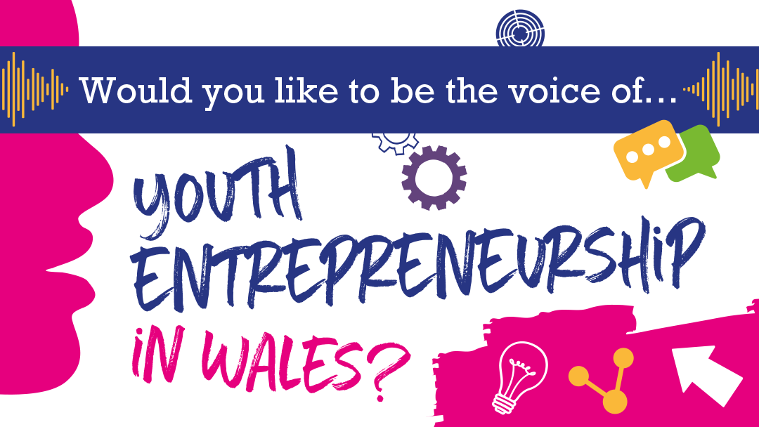
English Social Media Graphic: 1080 x 1080: (right click on the image and ‘save as picture’ to use)
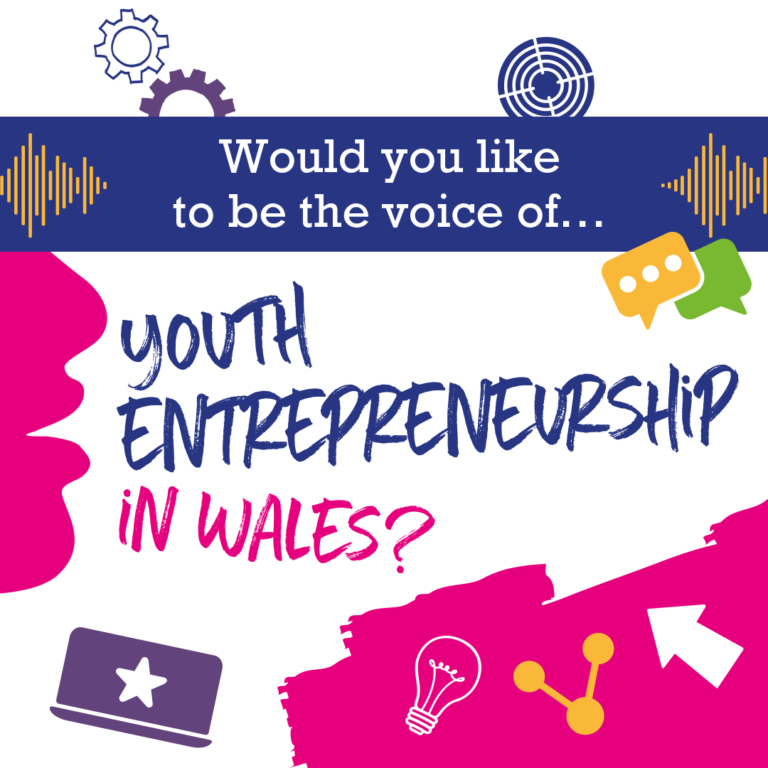
Welsh Social Media Graphic: 1080 x 608: (right click on the image and ‘save as picture’ to use)
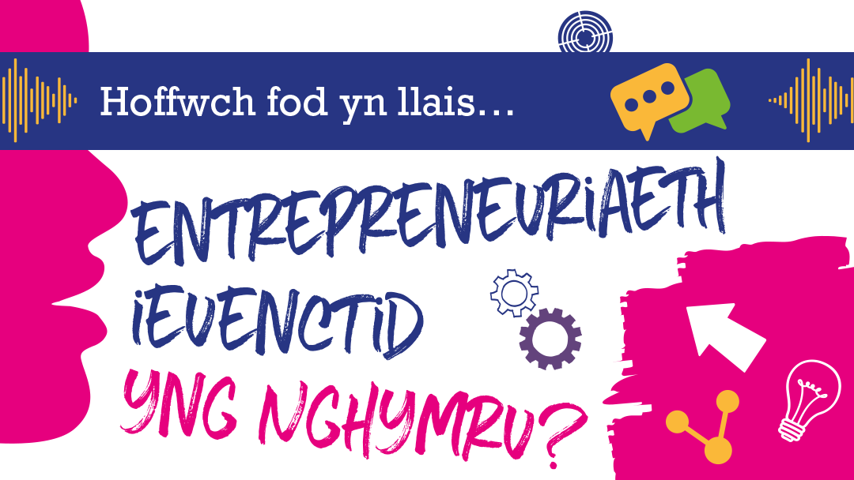

Welsh Social Media Graphic: 1080 x 1080: (right click on the image and ‘save as picture’ to use)

