An Introduction to
SMARTCymru - RD&I

To co-invest in business Research, Development and Innovation for sustainable growth

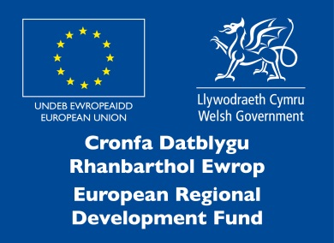

Contents

1. What is SMARTCymru RD&I? 3
2. Am I eligible to apply? 3
3. Are there any restrictions ……………… ………………………………………………….4
4. What type of funding should I apply for? 5
5. How do I apply? 6
6. When can I apply? 6
7. Assistance from Innovation Specialists 6
8. What should my application look like and what should it cover? 6
9. Confidentiality warning 7
10. Where do I send my completed application? 7
11. How will the Welsh Government decide which projects are supported? 7
Benefits to Wales: 7
Motivation: 7
Project Viability: 8
Value for Money: 8
12. What happens if I get Financial support? 8
13. When can I start? 8
14. How do I claim the funding? 9
15. What happens if I don’t get Financial support? 9
16. Research and Development Tax Credit………………………………………………….9
17. Complaints 9
18. Contact us 9
Appendix A - Approximate timescales for the application process 10
Appendix B - Scoring your application ……………………………………………………… ..11
Appendix C - Technical & Commercial Feasibility Report Guidelines 12
Appendix D - SME Declaration 17
Appendix E - Well-being of Future Generations (Wales) Act 2015 18

What is SMARTCymru RD&I?
The Welsh Government’s SMARTCymru RD&I (Research, Development & Innovation) funding and support scheme for Research and Development is primarily aimed at start up businesses and small and medium-sized enterprises (SMEs) already operating in Wales.

Its purpose is to co-invest in business Research, Development and Innovation for sustainable growth.

Business Finance is offered, at the discretion of the Welsh Government, to help businesses carry out research and development work that will lead to technologically innovative products or processes. Applications can be submitted at any time of the year. Proposals are assessed against selection criteria that include;

- Motivation - Why the business is carrying out the project. What benefits will it bring to the business.
- Benefits to Wales - What are the broader benefits in terms of new products and processes that benefit the economy and people of Wales.
- Project viability - What are the risks and technical challenges and how are these to be overcome.
- Value for Money – Are the costs associated with the project reasonable in line with the benefits that it will bring.

The proposal must demonstrate that grant funding support is essential to the project.

Am I eligible to apply?
The support scheme is primarily aimed at small and medium-sized enterprises (SMEs) already operating in Wales as defined below.

Small enterprise
- has fewer than 50 full-time employees (including partners and executive directors) worldwide;
- has either an annual turnover of no more than €10 million or an annual balance sheet total (a net asset value) of no more than €10 million; and
- meets the independence conditions below

Medium enterprise
- has fewer than 250 full-time employees (including partners and executive directors) worldwide;
- has either an annual turnover of no more than €50 million or an annual balance sheet total (a net asset value) of no more than €43 million; and
- meets the independence conditions below
EU State Aids
In addition, an enterprise is not classed as an SME if 25 per cent or more of its capital or voting rights are owned by another enterprise – or jointly by several enterprises – falling outside the conditions set out above. This limit can be exceeded only if the capital or voting rights are held by public investment corporations, venture capital companies or institutional investors; as long as no individual or joint control is exercised over the enterprise.
Also, an enterprise may not be classed as an SME if it (or any partner, director or substantial shareholder in it) is associated with, related to, or in any other way connected with any other enterprise where the total number of employees, turnover or balance sheet total (a net asset value), when added to those of the applying enterprise, exceeds the limits set out above.

Subject to current budget levels, SMARTCymru RD&I support has discretional capacity to support large enterprises which exceed the limits above. Large enterprises (non-SMEs) may apply for support with lower rates of funding described below.

Large enterprises (non-SMEs) may also apply for support with lower rates of funding described in the financial support table below.

Other forms of public funding will not normally be involved in a project that is being supported under this scheme. However, in order to ensure that European Community rules on accumulation of aid are respected, the Welsh Government will require the aid recipient to detail any other forms of public support they have received or likely to receive in relation to the same project. If additional government, (or EC), funding were involved, the usual accumulation rules will apply and the total government/EC funding for an individual project will not exceed the maximum aid intensities for the relevant phase.

An enterprise is not eligible to apply for Business Finance support for Research and Development if an academic institution has a shareholding of 50 per cent or more.

- Are there any restrictions?
Under the conditions of the financial support, you can only exploit the results of the project from premises located in Wales or deliver the benefits of the project to a location in Wales.

What type of funding should I apply for?
Different levels of financial support are aimed at different sized businesses and for different phases in the RD&I process

Description | Innovation Vouchers (IV) | Process Innovation (IV+) | Open Innovation Feasibility (OIF) | Feasibility  (F) | Industrial Research  (IR) | Experimental Development (ED) | Exploitation  (EXP)
Purpose of support | To bring in external expertise or equipment to develop, implement or exploit new or improved products or processes. | To implement a new or improved method of production, process or service delivery. | To enable your business to develop and adopt an Open Innovation culture and processes. | To support your business to investigate the viability of transforming your innovative ideas into new products, processes or services. | To help you undertake practical research that will allow the development of your idea into a proof of concept model. | To help you further develop the results of industrial research to demonstrate and validate them in real world operating conditions. | To assist with the exploitation costs of the newly developed product or process.
Deliverable | The development and/or introduction of an innovative product or process. | An upgrade to a process for a recently developed product, or First Industrial Deployment of a new process. | Development of an Open Innovation plan for your business and associated supply chains to enable collaborative R&D. | Development of a Feasibility study. | Development of a proof of concept model that demonstrates a technological advance and potential commercial viability. | Development of an advanced prototype or new product or process that demonstrates a significant technological advance and confirms viability. | The successful exploitation of a new product or process.
Eligibility | There are no restrictions on the size of business. |  |  | Small  < than 50 employees  ≤€10m turnover &/or balance sheet  Medium  < than 250 employees  ≤€50m turnover  ≤€43m balance sheet  Large |  |  | There are no restrictions on the size of business.
Project Criteria  Maximum % of eligible cost by company size:  Maximum Funding:  Location: | Up to 50%  (de minimis)  £10,000 Rev  £25,000 Cap  Must be in Wales | Up to 50%  Up to 50% for Large  (de minimis)  £100,000  Must be in Wales | Up to 50%  £30,000  Must be in Wales | Up to 70% for small  Up to 60% for medium  Up to 50% for Large  £30,000  Must be in Wales | Up to 70% for small  Up to 60% for medium  Up to 50% for Large  Funding can be enhanced by up to 15% to a maximum of 80% if the project is an effective collaboration involving at least one SME or a Research Organisation.  £100,000  Must be in Wales | Up to 45% for small  Up to 35% for medium  Up to 25% for Large  Funding can be enhanced by up to 15% if the project is an effective collaboration involving at least one SME or a Research Organisation.  £200,000  Must be in Wales | Up to 50%  (de minimis)  £20,000  Must be in Wales
Typical phase duration | Up to 6 months |  | 6 to 12 months. | 3 to 6 months | 3 to 12 months | 6 to 24 months | Up to 6 months
Payments | Paid against defrayed costs at project end. |  | Paid against defrayed costs, typically on a quarterly basis.

Some SMARTCymru RD&I applications may demonstrate an exceptional level of innovation, which on completion would provide a major impact to the future Welsh economy. These projects may apply for higher levels of support subject to current budget levels and the level of innovation. This funding is discretionary and you must work with our Sectors and Business team colleagues to provide comprehensive justification to exceed maximum levels of support.

How do I apply?
You will need to contact your Innovation Specialist in order to arrange a meeting to discuss your project and it's eligibility for support. If your business and project are eligible you will be asked to complete an Application for Financial Support form.

Your application should be focused and clear rather than lengthy and wordy. You should concentrate your case on the conditions for support. If you need any guidance, please speak to your lnnovation Specialist or the Innovation team. Your local Innovation Specialist should be able to help you prepare a proposal and give you guidance on what other help is available and appropriate at your stage of business development.

Our factsheet (Appendix A) shows the approximate timescale for the application and appraisal process

- When can I apply?
You can apply at any time. If your business and project are eligible, your Innovation Specialist will supply you with application documents. We may stop accepting new applications at any time. You should also remember that if your proposal is successful, the contract of offer of Business Finance will involve terms and conditions

Assistance from Innovation Specialists
When considering the development of new products and processes, our Innovation Specialists can help make sure that you get the right help at the right time. These experienced advisers offer information and guidance on all aspects of technology and innovation. They act as a gateway to many of the services the Welsh Government offers to businesses in Wales including:

- Quick and accessible guidance on new product and process development along with innovation.
- Connecting your business to the expertise and facilities within Universities and colleges in Wales - from problem solving through to access to specialised kit.
- Help with opportunities to learn how to identify and protect IP.
- Promotion of opportunities for your business to work on technology collaboration and transfer.
- Advice on how to access EU and UK financial support for R&D.
- Access innovation and technology based networks.

For details of your local Innovation Specialist please use the following link:
https://businesswales.gov.wales/expertisewales/support-and-funding-businesses/speak-someone-find-local-innovation-specialist

- What should my application look like and what should it cover?
Please avoid using jargon, and focus your description on the most important areas of the project. Keep the proposal simple (supported with any technical papers), and develop your case for support in line with the conditions. We are not looking for an in-depth scientific paper. We just want a few properly prepared pages of detail to help us get an idea of what the project involves and its potential as a technological innovation that could lead to lasting business growth.

- Confidentiality warning
If you have not already done so, you should consider protecting your intellectual property (for example, by patenting your idea or registering your design) before you discuss your proposals with anybody else. Our Innovation Specialists can offer guidance. For patenting purposes, sending in an application to us is not prior disclosure (that is, it does not affect your right to apply for a patent).

We may refer your application to Government departments or outside organisations, such as the National Engineering Laboratory, that have sources of technical expertise to help us assess your proposal. We have contracts or agreements with technical advisers that will make sure we keep your proposal confidential.

If you do not want us to get advice from any of these organisations, you must let us know when you send us your project application. If we cannot find a suitable source of advice from our list, we will ask you to help identify another independent, competent and recognized organisation. In such cases, we will take steps to make sure that we keep your proposal strictly confidential. If we cannot get the advice that we need, it will prejudice your funding application.

- Where do I send my completed application?
Please email your completed application and accompanying documents to
SMARTCymru@gov.wales

If any details within your application change after you send us your application and before we make a decision, you must tell us immediately in writing. If you do not, we could withdraw any offer of support we make if your application is successful.

How will the Welsh Government decide which projects are supported?
We are looking for projects that involve researching and developing innovative
technologies, which will ultimately form the basis of sustainable business development or growth. We will assess your project under the following headings:

Benefits to Wales: We will carefully consider the level of technological innovation involved with the proposed work. This means that we will consider whether the project involves novelty (by which we mean new to an industry or market), technological innovation (by which we mean a technological development that will form an improved alternative or the basis of a significant improvement over existing products or processes) and/or technology advance (by which we mean a step advance over existing technologies).

Motivation: We will consider the potential long term benefits to the business such as increased capability, increased profit, new products, increased employment, reputational benefits etc. Alongside, an assessment of the project’s fit with the long term strategic objectives of the business. We will also look at the potential for commercialisation; including whether there is a market for the product or process, the size of the market, and how you plan to access the market. We will also examine the commercial risk, and likelihood that the full benefits of the project can be realised. This will take into account possible changes in the market, legislation and competitor activities.

The Welsh Government is committed to adopting and promoting best practice in its delivery of business support throughout Wales. The Welsh Government is keen to work with innovators who show a commitment or desire to embrace the Well-being of Future Generations (Wales) Act 2015. Further information on the act is available at Appendix D.

Project Viability: We will consider the technical challenges that must be overcome, any technical risks, and whether or not the plans to deliver the outputs and outcomes are realistic and achievable. We will examine the suitability of systems in place for management, legal compliance and financial management of the project. Sufficient resources such as staff, facilities and external expertise should be available to enable the business to successfully deliver the project. Consideration will also be given to the Intellectual Property Rights (IPR) position to evaluate the freedom to operate, and the potential to register new IPR as a result of the project.

Value for Money: We will consider to what extent the project provides value for money in that it makes the optimal use of resources to achieve intended outcomes; ensures costs are minimal for the resources required whilst taking quality into account; ensures outputs are appropriate for the level of investment. The business must demonstrate that the financial support is essential to the project. Without support the project would either not proceed or would only proceed so slowly as to risk losing competitive position or missing commercial opportunities.

Details of how these different areas are weighted in our assessment is covered in Annex B

What happens if I get Financial support?
If your application is successful, we will send you a formal contract offer letter confirming the programme of work, eligible costs, start date and timescale. It will also include the terms and conditions that we will ask you to accept. You must read the offer letter carefully; by agreeing to it, you will be entering a legally binding agreement with the Welsh Government. If you do not keep to the terms and conditions that apply to the offer we may ask you to pay the financial support back. We will appoint a Case Officer, who will visit you in order to monitor progress. We will set out arrangements for monitoring in the offer letter. If any problems arise during the project phase (for example, the work falls behind schedule) you should contact your Case Officer. Their role is to support you and help resolve any issues, so that the work can be completed satisfactorily. We may also ask your local Innovation Specialist to visit you to discuss progress and other ways of helping your business.

- When can I start?
If we offer you financial support, we will agree a start date with you and this date will be included in your offer letter. Work carried out before the agreed date will not be eligible for support.

- How do I claim the funding?
You will usually claim back the money spent on the work every three months, a claim form is available for your use. All claims should be supported by a progress report detailing results to date against objectives and timescales.

For Technical and Commercial Feasibility projects, it is usually the case that one claim only should be submitted at project completion. This should be submitted with a copy of the completed Technical and Commercial Feasibility Report. However, claims at 3 month intervals will be considered.

- What happens if I don’t get Financial support?
We will give you clear reasons for our decision in writing. You can discuss possible alternative sources of funding with your Innovation Specialist.

- Research and Development Tax Credit
You may be eligible to benefit from the UK government’s Research and Development Tax Credit Scheme (or R&D Tax Relief), under which you may be entitled to enhanced relief on qualifying R&D expenditure even that which is grant aided.

Further information, including guidance on “qualifying” expenditure, is available at
www.hmrc.gov.uk/ct/forms-rates/claims/randd.htm or from your local tax office. You should seek advice from your accountant or tax adviser before making a claim. RD&I support is classed as ‘notified state aid’ when considering R&D tax credits.

Complaints
We are committed to improving our standards of customer service. All complaints will therefore be taken seriously. If you have a complaint about the standard of service we have given you, please get in touch with the Appraisal Officer in the first instance. If your complaint is still not resolved the Appraisal Officer will let you have details of our complaints procedure that is set out at www.wales.gov.uk.

Contact us
You are able to contact us with any enquiries at SMARTCymru@gov.wales

Appendix A - Approximate timescales for the application process
Activity | Who is responsible? | Example Timeline  (Week number) | Comment
Project Scoping | Applicant | - | You may have scoped the idea over many weeks. The final scoping could be undertaken with input from the Innovation Specialist if required.
Determine if SMARTCymru funding is appropriate | Innovation Specialist | 1 | This will be done in discussion with the applicant; the IS may refer back to the Innovation Team for advice.
Application submission | Applicant | 3 | Please ensure all the documentation required is submitted. Requests for outstanding information will delay the start of the appraisal process.
Appraisal  1. Eligibility checks e.g. accounts, SME status.  2. Technical appraisal.  3. Third party evaluation (IP searches, external technical expert appraisal). | Technical Appraisal Officer | 7 | The appraisal process starts when all the required documents are submitted.  With a good application that satisfies all the internal and 3rd party requirements the appraisal process will take typically 4 weeks from submission  If the 3rd parties highlight clarification is needed we will need to spend further time discussing your application with you
Appraisal submitted for approval | Technical Appraisal Officer | 8 | The application is submitted to the Appraisal Team Manager for consideration for approval.
Application approved or rejected and applicant advised by letter | Appraisal Team Manager | 8

Appendix B - Scoring your application
The following illustration shows how the application form fits together with the SMARTCymru criteria. Each application is assessed against the 4 criteria with associated weighting.
Aim of SMARTCymru : To co-invest in business research, development and innovation for sustainable growth
Section 1: Project Summary - The essential details;
- Project Title
- Funding Requested
- Public Domain Abstract (The project in your words)
The application form
Value for Money
12% of score
Value for money for our investment
Project Viability
28% of score
Assessing the technical challenges and project management
Motivation
32% of score
Measuring benefits to the business and long term sustainability
Benefits to Wales
28% of score
Measuring the strategic fit and potential outputs
SMARTCymru
Criteria
Section 10: Declaration
Section 9: Supporting Document s
Section 8: Other Public Sector Funding investigated
Section 7 : Project Funding
- How the project will be financed
Section 6: Project Costs
- The resources needed for the project
- How those resources are used
Section 5: Benefits to the Business and Wales
- Impact of the Innovation on your business
- The benefits to the wider economy and society
Section 4: The Project
- The issue it resolves
- The Current market and future trends
- Intellectual property considerations
- Project Phase Plan
Section 3 : Current Business Activity
- Where is the business at now
- Products & Services you offer
Section 2 : Applicant Details
- Business Details
- Staff Numbers & Turnover

Appendix C - Technical & Commercial Feasibility Report Guidelines

The purpose of the Technical & Commercial Feasibility (TCF) phase is to convince project stakeholders (including The Welsh Government) that the idea you have for research and development is worth spending the considerable time and money it will take to develop from concept to a product or process ready-for-market and beyond.

These guidelines should be used to prepare a report resulting from a Technical and Commercial Feasibility phase and also to prepare a report that supports an application for an Industrial Research or Experimental Development project.

To this end, you must report on a number of topics relating to the concept to help you mount a strong, early challenge to your idea. All of the following topics and related questions should, at least, be answered in the report. In this report evidencing the method of reaching your conclusions is as important as the conclusions themselves and demonstrates the robustness of your approach.

Each of the topics must be addressed in their own individual section within a written report which follows the order and topic headings as illustrated below (in order to facilitate our monitoring processes). Any pictures, high level diagrams, charts and graphs you feel may enhance the report are also to be encouraged.

Welsh Government free help for you to Commercialise your Project
Whilst the primary aim of the Technical & Commercial Feasibility report is to provide confirmation that the project is both technically and financially achievable, and has real potential for commercial exploitation, the Welsh Government may also be able to use the information presented in the report to offer additional help for the applicant in exploring commercialisation options.

To be able to carry out this commercialisation support, the Welsh Government will need to pass on some of the contents of the TCF report to a third party (e.g. to potential investors, potential academic/business collaborators, and (where possible) to an external organisation for a commercial valuation of the potential intellectual property generated by this project. This information will only be released by us with your prior consent.

If you are interested in using this additional free service from the Welsh Government, and there are sections of your TCF report which you wish to remain confidential, please clearly indicate those sections to us in your TCF report document.

With your agreement, the non confidential information in the TCF report will form the basis on which we offer a range of services intended to improve the commercialisation opportunities for your business. These commercialisation services can include:
- Registration on the Enterprise Europe Network
- Registration for the Welsh Government’s Technology & Innovation Newsletter
- Trade missions; International Trade Opportunities
- Trade show information
- Investment opportunities
- Intellectual Property Valuation/ Registration service
- Identification of collaborative opportunities with other companies/Universities.

Data Protection Act
We will need to use the personal information you have provided in your original application and the TCF report to help us provide this service, and for monitoring and statistical purposes. We may disclose your information to other business service providers for these purposes. We may also contact you to evaluate our service.

Except where required by law, we will only pass on your information with your consent.
We would like to remind you that you have a right to see any information we hold about you, and you have a right to correct any inaccuracies in it.

Technical and Commercial Feasibility Report Format
To create an effective TCF report that will hopefully lead to a commercially successful R&D project, your report should cover all of the following key aspects:

Executive Summary
This should introduce the concept you are interested in developing, a brief summary of the work you have carried out during the Technical and Commercial Feasibility phase as well as setting out the key findings and conclusions. Include a project title, plus a one paragraph summary to explain your product or service and how it will be commercialised.

Technology
Concept Description
- Give a clear and concise description of how your concept works, understandable to a person without expertise in your field and give a description of the envisaged product/process.
Customer Requirements
- What specifications and functionality have you established as critical to the success of your concept in meeting customer requirements?
- How did you arrive at these requirements?
- How many potential customers did you successfully contact and at what level of seniority?
Technical Challenge
- What are the specific areas of technical challenge which will be addressed going forward?
- How did you identify these technical problems?
Technical Feasibility
- What technologies and approaches have you considered to meet these technical problems?
- Which technologies and approaches have you decided upon?
- Why are you confident that those you have selected offer the best approach?
- Which of these are effectively “off-the-shelf” solutions and which of these will require in-house development by your team?
- Why are you confident that your team has the skills to carry out this in-house development?
- Who will be providing any external expertise that is required?
- Why are you confident of their ability to deliver?

Commercial Attraction
Market Need
- What problem does your concept seek to address i.e. why is there a ready market for it?
Key Selling Points
- What is the problem, issue or opportunity your project aims to address?
- What are the benefits of this innovation or product to the end user/s?
- Who will benefit from the development of this innovation?
Market Focus
- Which markets did you consider?
- Which particular market sector/sub-sector is likely to be your primary focus initially?
- Why?
- In which countries do you currently intend to sell/license your developed concept initially?
- Why?
Market Size & Characteristics
- How big (£m’s) is this potential market sector/sub-sector in these locations currently?
- What trends are operating within these markets?
- Please provide the source of your data on the market and any assumptions you have used in arriving at your figures.
Customers
- Who in these markets are most likely to be your customers?
- What will be the benefits of this innovation to the end users and why?
- How close are you to your potential customers currently?
- What level and type of support can you expect from them with your product/process development?
- How will you ensure that your developing concept remains as close to what your customers want as possible and that any changes in specification or functionality are acceptable?
Product Pricing
- How much would potential customers be willing to pay for your completed concept?
- How does this compare with your expectations?
- How do you intend to deliver your concept on a commercial scale i.e. manufacture in-house, sub-contract manufacture, license the technology to others etc.?
- What are your expectations of the manufactured unit cost of your developed concept?
- How has this been calculated?
Sales & Marketing
- How do your potential customers currently find out about and buy competing product/processes e.g. direct sales, via distributors, via internet, licence, rent, purchase out-right etc.?
- How do you intend to market and sell your product/process?
- If this is different, why?
Existing Competition
- What work have you done to convince yourself that you have identified all of the significant competition that currently exists?
- What are the current competing products/processes and who offers them?
- What prices does your competition charge?
- What are the expected advantages and disadvantages of your developed concept compared to the competition?
Future Competition
- What other potential competition exists in this market?
- How do you believe your product / process would stand up to this and why?
- How have you gone about finding out about the potential competition?
- What do you anticipate the necessary “time to market” to be to optimise the commercial success of the concept?
- Why?

Intellectual Property
Patentability
- When were the patent searches carried out to satisfy you that there are no existing patents or designs which will infringe on your idea?
- Who carried them out? Please note only in exceptional circumstances will a search carried out by someone other than a suitably qualified, independent agent be accepted.
- What key words / phrases were used to carry out the search?
- What were the results of the search and the agent’s advice (this should indicate what is potentially patentable, include a list of any patents found that could possibly infringe on your design and how you intend to overcome any such problems)?
- What is potentially patentable?
- What would be the costs associated with your IP protection plan?
Other Protection
- How have the competitors you have identified protected their IP?
- What are your intentions as to protecting the range of new IP from the project? (Copyright, registered trade mark, registered design, patents (UK and/or other territories), trade secret etc.)
Third Party IP
- If you intend to use third party methods or technology in your design who are the holders of the relevant IP and are they willing to licence / sell it to you?

Approach/Route to Market
How will you achieve your objectives?
What will be your approach? e.g.:
- To collaborate with another organisation that can make use of your IP so they can develop a concept ready for market.
- Find support or investment to further develop and protect a concept yourself so it can be presented to potential investors or partners
- Find support or investment to develop a product that you will manufacture and promote yourself, say via
  - Partnership for production,
  - Distributor
  - Agent

Project Planning & Resources
- How much do you anticipate the overall concept development to cost?
- How has this been calculated?
- How do you intend to fund this development cost?
- How far advanced is the fund raising for this?
- What are the risks to the business of taking, and not taking, this development forward?
- Where will the next phase of the development take place and for how long?

Return on Investment
- Over what time period do you expect to make a return on any investment?
- Which option best describes the kind of return that you are expecting? e.g.
  - Royalties based on sales based on commercial use of your IP
  - A one off fee for the sale of your IP
  - An initial fee and royalties based on the commercial use of your IP
  - Increased sales or wider distribution of your own product/service

Appendix D - SME Declaration

Please refer to the document - User guide to the SME Definition which is available from either your Innovation Specialist or the web site below.

http://ec.europa.eu/DocsRoom/documents/10109/attachments/1/translations/en/renditions/native

A model declaration form is available on page 46 of the document.

If the company is Partnership or linked enterprise there will be a requirement to fill in the relevant annexes to the SME Declaration.

Page 46 provides a model declaration form that can be used.

Page 49 provides a calculation for the partner or linked type of enterprise.

Annex A provides the relevant forms for Partnerships and Linked Enterprises (pages 50 and 51 for Partnerships or pages 52 to 54 for linked enterprises).

Appendix E - Well-being of Future Generations (Wales) Act 2015

The Well-being of Future Generations (Wales) Act is about improving the social, economic, environmental and cultural well-being of Wales. It will make the public bodies listed in the Act think more about the long-term, work better with people and communities and each other, look to prevent problems and take a more joined-up approach. This will help us to create a Wales that we all want to live in, now and in the future. To make sure we are all working towards the same vision, the Act puts in place seven well-being goals.

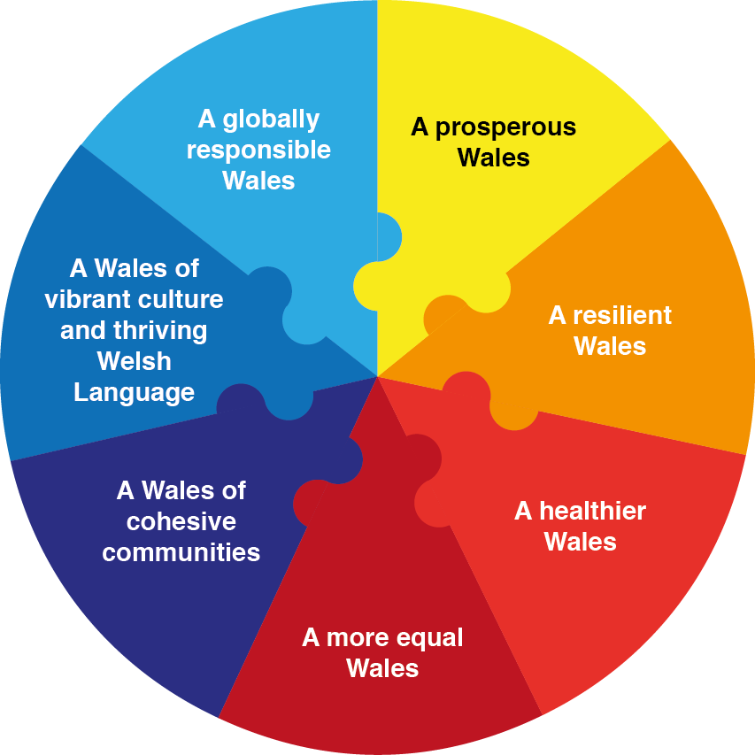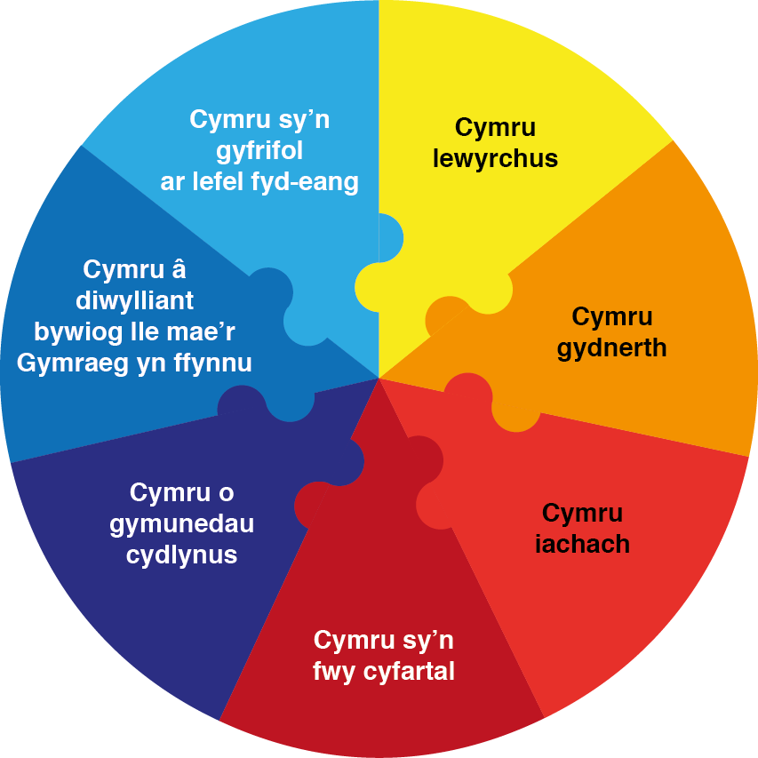

Web page - http://gov.wales/topics/people-and-communities/people/future-generations-act/?lang=en
The Welsh Government is looking to support initiatives that fit with these goals, and will therefore be looking at how the Innovation activity we support contributes to achieving them.

