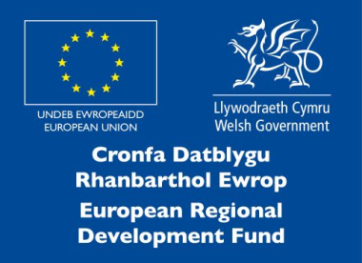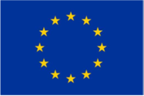

This project has received funding from the European Union’s Horizon 2020
research and innovation programme under the Marie Skłodowska-Curie grant agreement No 663830.
Sêr Cymru II Privacy Statement for funded applications
This privacy statement relates to applications which have been funded by the Welsh Government under the Sêr Cymru II Programme.
There is a separate statement which contains information on how we will process data provided as part of the application process. This can be found on our website.
The Welsh Government is required to collect information about those who have been successful in applying to the Sêr Cymru II Programme (the Programme) as part of its public task to administer the funding.
The Welsh Government will be data controller for any personal data provided to it as part of the post award process.
Information on those who have been funded by the Programme will be provided to UK and European auditors for audit purposes.
Information on those funded will also be passed to project funders for monitoring purposes.
Contact details of those funded will be passed to contractors for the purposes of research and evaluation but the findings of any research and evaluation studies will not identify individuals.
Welsh Government will retain information in accordance with the requirements of its funders and its own internal rules. This means that we will retain data until 31 December 2027 for ERDF funded activity unless we are advised otherwise. For Horizon 2020 funded activity, information will be retained until 31 July 2026.
For any general queries on this notice please contact the mailbox below:
SERCymruIIMonitoring@gov.wales

Under the data protection legislation, you have the right:

- to access the personal data the Welsh Government holds on you;
- require us to rectify inaccuracies in that data
- to (in certain circumstances) object to or restrict processing
- for (in certain circumstances) your data to be ‘erased’
- to lodge a complaint with the Information Commissioner’s Office (ICO) who is the independent regulator for data protection

For further details about the information the Welsh Government holds and its use, or if you want to exercise your rights under the GDPR, please see contact details below:
Data Protection Officer:
Welsh Government
Cathays Park
CARDIFF
CF10 3NQ

Email Address: DataProtectionOfficer@wales.gsi.gov.uk

The contact details for the Information Commissioner’s Office are:
Wycliffe House
Water Lane
Wilmslow
Cheshire
SK9 5AF

Telephone: 01625 545 745 or 0303 123 1113
Website: www.ico.gov.uk

