SMARTCymru - RD&I
Open Innovation
Feasibility Support

Guidelines for applicants

To co-invest in business Research, Development and Innovation for sustainable growth

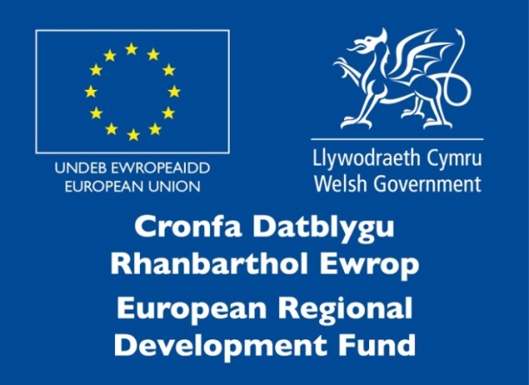

CONTENTS

Contents
1. What is SMARTCymru? 3
2. What is open innovation in our context? 3
3. Aims of the support 3
4. Key facts regarding Open Innovation Feasibility support 4
5. Typical Activities 4
6. Commitments 5
7. Expected outcomes and outputs 5
8. Am I eligible to apply? 5
9. How will the Welsh Government decide which projects are supported? 5
10. How do I apply? 6
11. What happens if I get Business Finance? 8
12. Complaints 9
13. Contact us 9
Appendix A - What type of funding is available through SMARTCymru RD&I?............10
Appendix B - Open Innovation Feasibility Report Guidelines.........................................11
Appendix C - Well-being of Future Generations (Wales) Act 2015……………………….13
Appendix D - SME Declaration…………………………………………………………………..14

- What is SMARTCymru?
Technological innovation is key for many businesses to improve competitiveness and to stimulate business growth.

The purpose of SMARTCymru RD&I (Research, Development & Innovation) is to co-invest in business Research, Development and Innovation for sustainable growth.

Business Finance is offered, at the discretion of the Welsh Government, to help businesses carry out research and development work that will lead to technologically innovative products or processes. Proposals are assessed against selection criteria that include the motivation behind the project, benefits to Wales, project viability and value for money. The proposal must demonstrate that grant funding support is essential to the project.

Support is available for 6 different phases of a research and development project. These guidelines are specifically for the Open Innovation Feasibility phase, information on the other phases is available in Appendix A.

- What is open innovation in our context?
The commercialisation function of SMART Innovation aims to build collaborative relationships between businesses which results in new products or processes being developed and introduced to new markets for profit.

Open innovation in our context is seen as collaborative innovation for the successful commercialisation of new ideas. Open Innovation assumes that organisations should use external ideas as well as internal ideas, and internal and external paths to market, as businesses look to advance their technology in line with their business model.

- Aims of the support
SMARTCymru Open Innovation Feasibility support enables businesses to undertake a study into how they could apply a strategic and managed approach to open innovation. The purpose is to explore if it is the right course of action and how might it be implemented, enabling businesses to develop and adopt an open innovation culture and processes.

The main outcome of the study will be an open innovation plan, providing the rationale and confidence for businesses to invest further resource to open innovation activities. It will provide the foundation for new processes for new product development, and cross sector fertilisation of existing technologies into new markets.

Support is best suited to businesses that want to offer multiple and ongoing opportunities for collaboration (please seek Welsh Government advice if you’re seeking support for a one off R&D project). There are numerous examples globally and within Wales of businesses benefitting from open innovation. Activity can lead to opportunities for other organisations (primarily SMEs and academia) to collaborate, providing solutions to industry and market led opportunities and challenges.

This document provides guidance to applicants completing an application for SMARTCymru Open Innovation feasibility support. You should refer to these guidelines to ensure you provide all of the required information and documentation that will enable Welsh Government to appraise your application.

- Key facts regarding Open Innovation Feasibility support
Amount
Up to £30,000 towards a maximum of 50% of the project costs. Projects with a value of more than £60,000 can be supported but will only attract a maximum of £30,000 funding.

Ineligible costs
- Capital spend
- Consumables
- Third party costs are limited to 20% of the overall funding

Length
Projects should span 6-12 months

Submitting an application
Completed applications should be submitted to SMARTCymru@gov.wales.

Assessment process and notification
See section 9 below for information on the assessment criteria.
Welsh Government will convene a panel to make a final decision.

- Typical activities
This list is not exhaustive and applicants do not need to address all of the activities outlined below.
- Explore the concept of open innovation and it’s applicability to the business.
- Explore best practice models for open innovation.
- Develop the methodology and governance for open innovation.
- Align with corporate strategy.
- Instigate an internal culture change.
- Identify collaborative partners (partner capability study).
- Identify and scope challenges that could be solved through technology adoption or development in partnership with others.
- Explorative workshops with internal and external stakeholders to scope new R&D/Innovation projects.
- Develop appropriate collaborative agreements and Intellectual Property management.
- Identify existing Intellectual Property that could be further developed or exploited by others.
- Explore new sectors and markets where existing capability could be utilised.
- Technology road mapping in line with business models and areas of focus for open innovation.
- Explore resources and funding required to undertake collaborative projects.
- Assess potential risks and commercial/economic benefits.
- Engage with CoInnovate, Wales’ flagship open innovation conference.

- Commitments
- Successful applicants will be expected to attend quarterly meetings organised by Welsh Government to share best practice.
- Successful applicants will join the Welsh Government’s Open Innovation Network.

- Expected outcomes and outputs

Note this list is not exhaustive
- An open innovation feasibility report and implementation plan for the business (See Appendix B for guidelines on the format and content of the report).
- Processes developed and adopted to instigate a culture change within the business to become more collaborative.
- An Identified list of stakeholders to collaborate with.
- A prioritised shortlist of potential collaborative projects.
- Identification of potential funding and resources for projects.
- R&D plans including technology, knowledge and capability gaps.

- Is my business eligible to apply?
Businesses must have a base in Wales, and projects must be undertaken in Wales.

Under the conditions of the financial support, you must also exploit the results of the project from premises located in Wales or deliver the benefits of the project to a location in Wales.

Other forms of public funding will not normally be involved in a project being supported under this scheme. However, in order to ensure that European Community rules on accumulation of aid are respected, the Welsh Government will require the applicant to detail any other forms of public support they have received or likely to receive in relation to the same activity.

Businesses are not eligible to apply for Business Finance support for Research and Development if an academic institution has a shareholding of 50 per cent or more.

- How will the Welsh Government decide which projects are supported?
Your project will be assessed against selection criteria to measure the suitability of the project in terms of innovation and value for money for the taxpayer. Funding will be offered at the discretion of the Welsh Government.

We are looking for projects that involve researching and developing innovative processes and technologies which will ultimately form the basis of sustainable business development or growth. We will assess your project under the following headings:

Benefits to Wales:
The project should improve the applicant’s capability to adopt open innovation activities in Wales. An assessment will be made whether activities undertaken in the Open Innovation Feasibility phase are likely to lead to increased technological innovation and technological development in Wales. Of particular interest is whether activities are likely to create collaborative opportunities for other stakeholders in Wales (such as SMEs and/or academia).

Motivation: We will consider the potential long term benefits to the business such as increased capability, increased profit, new products, increased employment, reputational benefits etc. An assessment of the project’s fit with the long term strategic objectives of the business will be made. We will also look at the potential for commercialisation of any future RD&I projects resulting from activities, including the markets in the technological areas of interest and how markets are accessed. We will also examine the commercial risk, and likelihood that the full benefits of the project can be realised.

Project Viability: We will consider the challenges that must be overcome, any risks, and whether or not the plans to deliver the outputs and outcomes are realistic and achievable. We will examine the suitability of systems in place for management, legal compliance and financial management of the project. Sufficient resources such as staff, facilities and external expertise should be available to enable the business to successfully deliver the project.

Applicants must have sufficient capacity to be able to offer multiple and ongoing opportunities for collaboration if open innovation approaches were to be successfully adopted following the feasibility study.

Value for Money: We will consider to what extent the project provides value for money in that it makes the optimal use of resources to achieve intended outcomes; ensures costs are minimal for the resources required whilst taking quality into account; ensures outputs are appropriate for the level of investment. The business must demonstrate that Business Finance support is essential to the project. Without support the project would either not proceed or would only proceed so slowly as to risk losing competitive position or missing commercial opportunities.

Well-being of Future Generations (Wales) Act 2015: The Welsh Government is committed to adopting and promoting best practice in its delivery of business support throughout Wales. The Welsh Government is keen to work with organisations who show a commitment or desire to embrace the Well-being of Future Generations (Wales) Act 2015. Further information on the act is available at Appendix C.

- How do I apply?
You will need to contact Mark Lewis, Commercialisation Manager, via mark.lewis2@gov.wales in order to discuss your project and its potential eligibility for support. If your business and project are eligible you will be invited to complete an Application for Financial Support form.

If you need any guidance, please speak to Mark Lewis who will be able to help you prepare a proposal and give you guidance on what other support is available.

We also have a team of Innovation Specialists that can help make sure that you get the right help at the right time when you’re thinking of developing new products and processes. These experienced advisers offer information and guidance on all aspects of technology and innovation. They act as a gateway to many of the services the Welsh Government offers to businesses in Wales including:

- Quick and accessible guidance on new product and process development along with innovation.
- Connecting your business to the expertise and facilities within Universities and colleges in Wales - from problem solving through to access to specialised kit.
- Help with opportunities to learn how to identify and protect Intellectual Property.
- Promotion of opportunities for your business to work on technology collaboration and transfer.
- Advice on how to access EU and UK financial support for R&D.
- Access innovation and technology based networks.

For details of your local Innovation Specialist please use the following link:
https://businesswales.gov.wales/expertisewales/support-and-funding-businesses/speak-someone-find-local-innovation-specialist

What should my application look like and what should it cover?
Please avoid using jargon, and focus your description on the most important areas of the project. Keep the proposal simple, and develop your case for support in line with the guidelines in this document. We are not looking for an in-depth business plan. We just want a few properly prepared pages of detail to help us get an idea of what the project involves and its potential to lead to lasting business growth.

Confidentiality warning
We may refer your application to Government departments or outside organisations, such as the National Engineering Laboratory, that have sources of technical expertise to help us assess your proposal. We have contracts or agreements with technical advisers that will make sure we keep your proposal confidential.

If you do not want us to get advice from any of these organisations, you must let us know when you send us your project application. If we cannot find a suitable source of advice from our list, we will ask you to help identify another independent, competent and recognized organisation. In such cases, we will take steps to make sure that we keep your proposal strictly confidential. If we cannot get the advice that we need, it will prejudice your funding application.

Where do I send my completed application?
Please email your completed application and accompanying documents to
SMARTCymru@gov.wales

If any details within your application change after you send us your application and before we make a decision, you must tell us immediately in writing. If you do not, we could withdraw any offer of support we make if your application is successful.

- What happens if my application is successful?
If your application is successful, we will send you a formal contract offer letter confirming the programme of work, eligible costs, start date and timescale. It will also include the terms and conditions that we will ask you to accept. You must read the offer letter carefully; by agreeing to it, you will be entering a legally binding agreement with the Welsh Government. If you do not keep to the terms and conditions that apply to the offer we may ask you to pay the financial support back. We will appoint a Case Officer, who may visit you in order to monitor progress. We will set out arrangements for monitoring in the offer letter. If any problems arise during the project phase (for example, the work falls behind schedule) you should contact your Case Officer. Their role is to help resolve any issues, particularly relating to timing, so that the work can be completed satisfactorily. We may also ask your Innovation Specialist or other members of our Innovation team to visit you to discuss progress and other ways of helping your business.

When can I start?
If we offer you financial support, we will agree a start date with you and this date will be included in your offer letter. Where practical, our aim is for all successful applicants to begin projects in a similar timeframe to benefit from attending best practice sharing meetings (organised by Welsh Government) with other successful applicants. Note that any work carried out before the agreed start date will not be eligible for support.

How do I claim the funding?
You will be expected to submit one claim at the end of the project. However, claims at 3 monthly intervals will be considered. The final claim at the end of the project should be accompanied by a Feasibility Report (see Appendix B).

Claims should be supported by a progress report detailing results to date against objectives and timescales. Further details on how to claim will be communicated if you’re successful with your application.

What happens if my application is unsuccessful?
We will give you clear reasons for our decision in writing. You can discuss possible alternative sources of funding with the Sectors and Business team or consider revising your application and resubmitting it at the next call.

- Complaints
We are committed to improving our standards of customer service. All complaints will therefore be taken seriously. If you have a complaint about the standard of service we have given you, please get in touch with the Appraisal Officer in the first instance. If your complaint is still not resolved, the Appraisal Officer will provide details of our complaints procedure that is set out at www.wales.gov.uk

- Contact us
You are able to contact us with any enquiries at innovation@gov.wales

Appendix A

What type of funding is available through SMARTCymru RD&I?
Different levels of financial support are aimed at different sized businesses and for different phases in the RD&I process
Description | Innovation Vouchers  (IV) | Open Innovation Feasibility (OIF) | Technical & Commercial Feasibility (TCF) | Industrial Research  (IR) | Experimental Development (ED) | Exploitation  (EXP)
Purpose of support | To help you bring in external expertise or equipment for the purpose of developing, implementing or exploiting new or improved products or processes. | To enable your business to develop and adopt an Open Innovation culture and processes. | To support your business to investigate the viability of transforming your innovative ideas into new products or processes. | To help you undertake practical research that will allow the development of your idea into a proof of concept model. | To help you further develop the results of industrial research to demonstrate and validate them in real world operating conditions. | To assist with the exploitation costs of the newly developed product or process.
Deliverable | The development and/or introduction of an innovative product or process. | Development of an Open Innovation plan for your business and associated supply chains to enable collaborative R&D. | Development of a Technical and Commercial feasibility report. | Development of a proof of concept model that demonstrates a technological advance and potential commercial viability. | Development of an advanced prototype or new product or process that demonstrates a significant technological advance and con70.  viability. | The successful exploitation of a new product or process.
Eligibility | There are no restrictions on the size of business. |  | Small  < than 50 employees  ≤€10m turnover &/or balance sheet  Medium  < than 250 employees  ≤€50m turnover  ≤€43m balance sheet  Large |  |  | There are no restrictions on the size of business.  Note: Restricted to businesses that have received support with at least one of the earlier phases.
Project Criteria  Maximum % of eligible cost by company size:  Minimum phase cost:  Maximum Funding:  Location: | Up to 50%  Up to 50% for Large  (de minimis)  None  £10,000 Rev £25,000 Cap  Must be in Wales | Up to 50%  £15,000  £30,000  Must be in Wales | Up to 70% for small  Up to 60% for medium  Up to 50% for Large  £5,000  £15,000  Must be in Wales | Up to 70% for small  Up to 60% for medium  Up to 50% for Large  Funding can be enhanced by up to 15% to a maximum of 80% if the project is an effective collaboration involving at least one SME or a Research Organisation.  £30,000  £100,000  Must be in Wales | Up to 45% for small  Up to 35% for medium  Up to 25% for Large  Funding can be enhanced by up to 15% to a maximum of 80% if the project is an effective collaboration involving at least one SME or a Research Organisation.  £60,000  £200,000  Must be in Wales | Up to 50%  (de minimis)  £5,000  £20,000  Must be in Wales
Typical phase duration | Up to 6 months | 6 to 12 months. | 3 to 6 months | 3 to 12 months | 6 to 24 months | Up to 6 months
Payments | Paid against defrayed costs at the end of project. | Paid against defrayed costs, typically on a quarterly basis.

Appendix B
Open Innovation Feasibility Report Guidelines

At the end of the project you will be expected to submit to Welsh Government a report that contains the following sections and topics.
Each of the topics should be addressed in their own individual section within a written report following the order as illustrated below. If any section isn’t relevant to your project please state this providing reasons why.
You should also include any images, diagrams, charts and graphs or other information you feel adds value to the report.
Executive Summary
- A summary of your approach and the work you carried out
- A brief overview of the key findings and conclusions.

Best practice open innovation practices from elsewhere
- What research did you undertake to develop your thinking?
- What did you learn from others, and who were they?
- What value did they add?

Stakeholders identified
- Industry?
- Academia?
- Government?
- Customers?
- Staff?
- Networks/clusters?
- Others?

Processes
- What processes are required to enable you to adopt open innovation?
- To what degree have they already been adopted?
- If you wish to adopt Open Innovation, what new processes are required and what are the likely timescales to implement them?

Implementation plan
- How did it evolve?
- Did you keep to the plan?

Barriers
- Have you experienced any barriers to adopting open innovation?
- How will or have these been overcome?

Culture Change
- What steps did you take to implement or encourage a culture change?
- How do you plan to extend this further?

Management & Governance
- What management processes are required to effectively implement open innovation?
- What governance is required?
- Do you have formal collaborative and non disclosure agreements
- What is the businesses approach to Intellectual Property?

Benefits
- What are the potential benefits to your business of adopting open innovation?
- What opportunities does it create for yourselves and others?
- How will success be measured?

Financial
- If continued, how will open innovation practices be funded in the future?
- What sources of funding have been identified to support any resulting R&D projects?
- Has any funding for innovation/R&D been secured as a result of the feasibility study?

Projects
- Have any new projects been undertaken as a result of open innovation activities?
- Are any projects planned in the future as a result of open innovation activities?
- Are these projects collaborative in nature? (provide a list of the other organisations)
- Have any challenges or opportunities been identified that could be solved through collaboration with others?

Conclusions and Future Steps
- What have you concluded from the open innovation activities to date?
- Will open innovation activities continue beyond this feasibility phase?
- If so, to what scale will they be continued? e.g. same level, expanded, reduced.

Appendix C

Well-being of Future Generations (Wales) Act 2015

The Well-being of Future Generations (Wales) Act is about improving the social, economic, environmental and cultural well-being of Wales. It will make the public bodies listed in the Act think more about the long-term, work better with people and communities and each other, look to prevent problems and take a more joined-up approach. This will help us to create a Wales that we all want to live in, now and in the future. To make sure we are all working towards the same vision, the Act puts in place seven well-being goals.

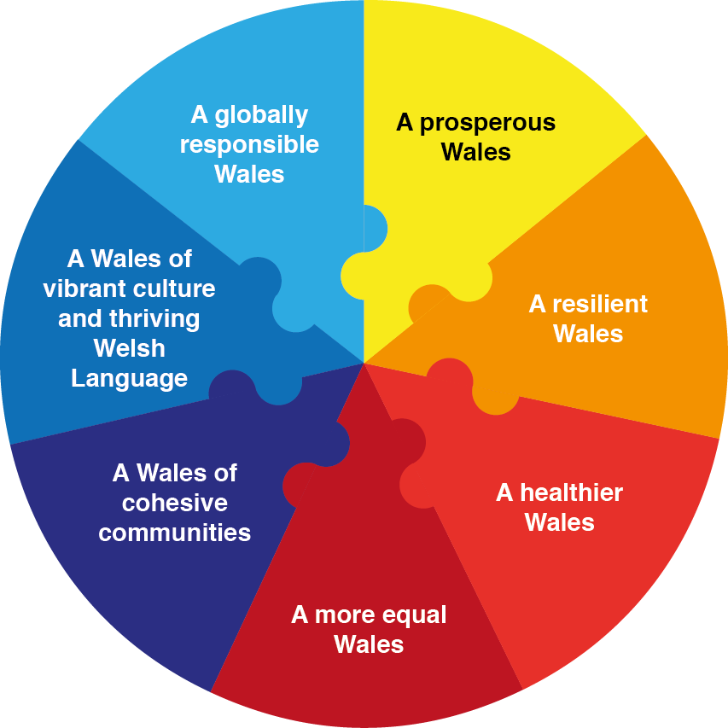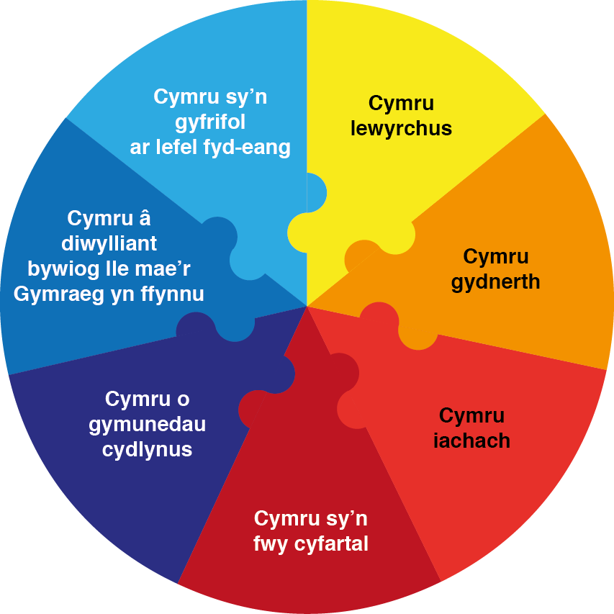

Web page - http://gov.wales/topics/people-and-communities/people/future-generations-act/?lang=en
The Welsh Government is looking to support initiatives that fit with these goals, and will therefore be looking at how the Innovation activity we support contributes to achieving them.

Appendix D

SME Declaration

Please refer to the document - User guide to the SME Definition which is available from the web site below. You only need to complete the declaration if your business is an SME.

http://ec.europa.eu/DocsRoom/documents/10109/attachments/1/translations/en/renditions/native

A model declaration form is available on page 46 of the document.

If the business is a Partnership or linked enterprise there will be a requirement to fill in the relevant annexes to the SME Declaration.

Page 46 provides a model declaration form that can be used.

Page 49 provides a calculation for the partner or linked type of enterprise.

Annex A provides the relevant forms for Partnerships and Linked Enterprises (pages 50 and 51 for Partnerships or pages 52 to 54 for Linked Enterprises).

