Marketing Red Meat.

Rebecca Williams
Farming Connect Management Exchange
Traveling the UK 2022
I’m Becca Williams, 24 years old and I am a farmer’s daughter, I live and work on our family farm. We are a 400-acre beef, sheep and venison farm in Mid Wales where I have worked full time for five years. We keep 24 Welsh Black cattle, 700 sheep, and 82 red deer. I have had no formal agricultural education however after being very lucky to have been involved in both the Farmers Weekly Apprentice scheme and the Tesco Future Farmer Foundation, I am very keen to learn as much as I can about the industry that I have found such a passion to work in. After I headed up the ‘big push’ for our business to take on the venison enterprise, obviously I want it to be a success. I realised I didn’t have a lot of knowledge about the industry beyond the producing side so I started looking into different ways to sell our product. Starting my research one of the first things I did was just simply to search the words ‘Red Meat’ online as I tried to get into the mind of the public, and those interested in educating themselves, and instantly found what I consider to be an issue.
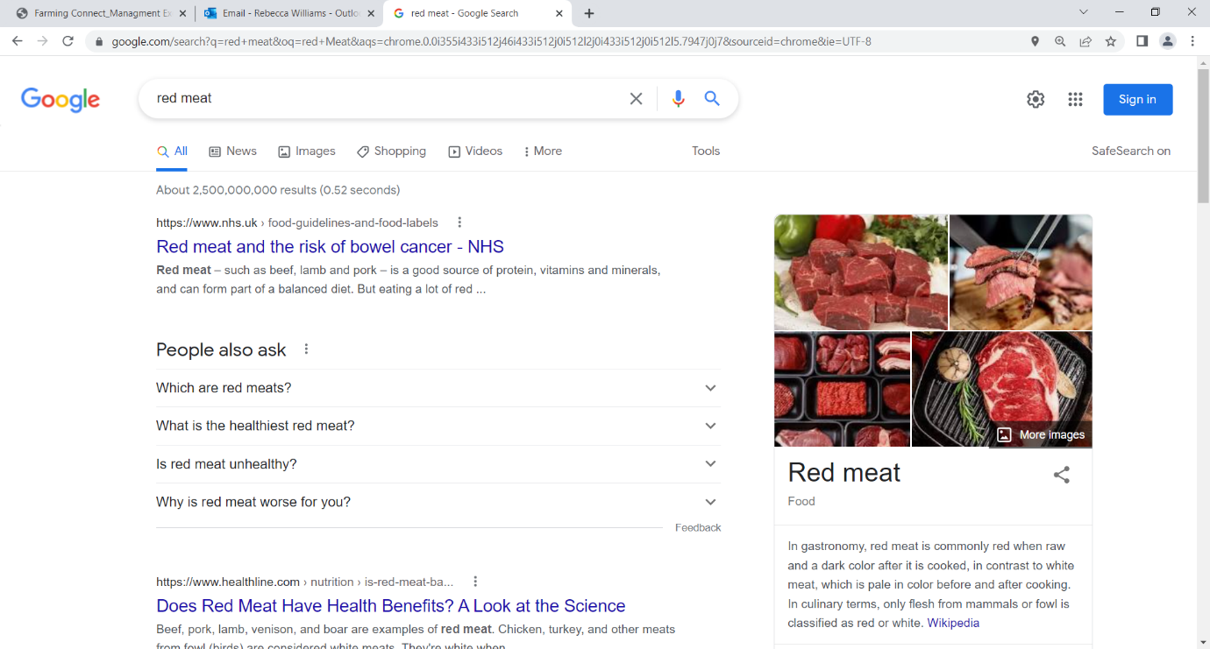(Image 1 taken from Google, showing the top hit responses when ‘red meat’ is searched.)

I saw that there are three stand out points; ‘Red Meat’, ‘Bowel Cancer’ and ‘NHS’. These are top of the search (this being rated by how many people have clicked on it) so red meat being advertised as a negative health risk from what most individuals would say is a reliable source. If you click on the link the article explains how Meat ‘can form part of a balanced diet’, but in my opinion I believe it is still biased towards not eating meat and anyone reading this and wanting to learn about what should be in their diet or wanting to get involved in the industry, is going to be off put. Personally, I think that as an industry we should look to advertise ourselves. The meaning of marketing applies to activities taken to promote the buying or selling of a product or service. For the most part this includes advertising, selling, and delivering products to consumers or other businesses.

Key Points I want to look at:
- What’s already being done
- How we can reach or educate the public on the benefits of eating meat
- Do we need to worry about food trends? (E.g., Veganism, Vegetarianism)
- What can I and others do to assist?

To see what is already happening, my first point of call was a chat with Hybu Cig Cymru/Meat Promotion Wales’s (HCC) Mr Rhys Llywelyn. HCC is a levy funded organisation, roughly £4 million from Welsh farmers and processors, with an additional £1m from animals that are born and reared in Wales but are often finished and slaughtered in England (repatriated levy). This money is used for market development, industry development, consumer marketing campaigns, protecting the ‘PGI’ (Protected Geographical Indication) for Welsh lamb and beef, creating a simple titled message for consumers to understand. PGI – is a way of recognising a specific geographical area that produces high-quality food and drink. This means that PGI Welsh Lamb and Welsh Beef is different, has special characteristics that are unique to Wales and cannot be replicated anywhere else. As well as TV, Radio and Online work. HCC has a website that has simple well explained recipes which look delicious and have memorable titles such as ‘simply splendid steak’ using alliteration to catch the attention of the reader. It also has educational tools for the viewer with a ‘Know Your Cuts’ tab.
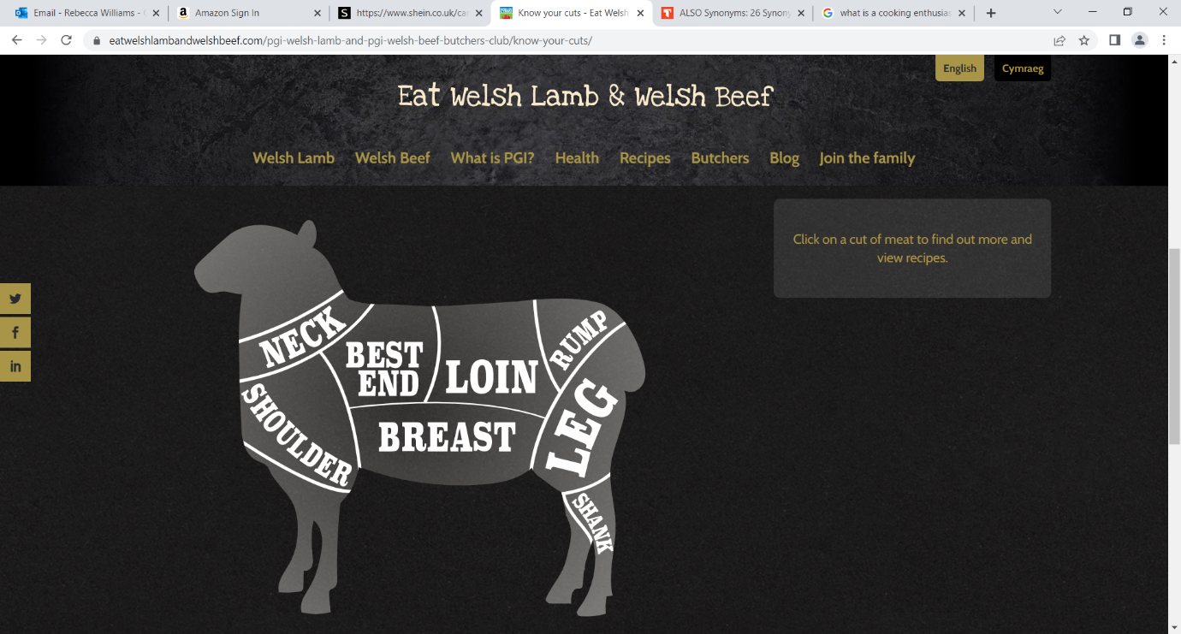
(Image 2 taken from the https://eatwelshlambandwelshbeef.com website showing an example on lamb cuts.)
HCC also have a Facebook page along with a Twitter and Instagram account to advertise their message to others in a modern way, younger to reach the younger generation. Other work to educate and advertise red meat to the next generation has seen HCC create a ‘First Degree Cooking for Students’ booklet which they hand out at student fairs, educating readers on healthy, cheap and fast red meat recipes. When thinking about who is purchasing red meat products Rhys Llywelyn said they don’t wish to waste time by trying to convert those who follow a vegan or vegetarian diet, direct their aims towards the ‘young mum’ who is thinking about sustainability and health. As well as the older generation who have a greater disposable income, ‘foodies’ and gym goers who look for ‘high quality food and protein’, the largest portion of their budget is spent on targeting these individuals. Rhys Llywelyn also told me about how they are talking to Nurses and Specialists about the negative messages being advertised around red meat, adding that they must be careful about what they say on this subject, to not spread false rumours to the public before knowing all the facts.

When looking at how we can educate the public and ‘catch their eye’ so to speak, Professor David Hughes or ‘Dr Food’ as known by many, was very helpful with his incite. He told me about how the idea that you have a ‘story’ to sell along with your product, so the public feel they know more about what they are consuming and possibly because they are more interested in the sustainability of the food they are consuming. Prof Hughes also explained how it is important to know who your customer is. The future will be driven almost purely by price, but being aware that most of the public who are aged under 40 currently, don’t know about ingredients, and only think of food as a whole meal. The red meat industry needs to create a quick meal which has the ‘cooked in 20 minutes at 180 degrees’ ideal. As an industry we should also be more mindful of the naming of our finished product. To take chicken as an example, probably the best-selling product would be chicken ‘nuggets’, which ‘sounds’ very family friendly, many of the general public have a disconnection from their food. They don’t wish to be reminded they are eating a ‘shoulder’, a ‘rib’ or a ‘leg’. Another change to the market Prof Hughes educated me on, is that there are no longer the two markets of food. These being to eat out, and food to have at home. Supermarkets now sell a meal as a whole, which you could only purchase at a restaurant in the past. Also outdated is the idea of ‘three meals a day’, a modern diet is to simply eat when we are hungry, so pushing to get ‘snack type’ products such as beef jerky available to consumers should be a priority.
It could be beneficial to advertise meat as environmentally friendly because the wider perception is that it has a negative impact, however in reality it does depend on how it is produced. We should be promoting more about the health benefits, currently there is almost nothing on the packaging explaining this, so this adds to the disconnection the current public has with their diet, it needs to be explained simply and obviously.
Meat products should use the fact that our produce have the short ingredient list of only ‘lamb’ or only ‘beef’, comparing to meat substitutes which have long lists of ingredients to create the replacement product. And also, the fact that, as a general rule the public trust farmers more than any other part of the food supply chain. We must also believe in transparency, and as an industry we must have nothing to hide.
(Image 3 supplied from presentation Professor David Hughes uses for his talks about how consumers build their trust with food.)

Professor Hughes also has an incredible knowledge on food trends, so when talking to him I took the time to ask him his opinions on one of my other investigative points for the exchange. He expressed how the covid 19 pandemic has had such a large effect on the publics diet. Growing the sales of ‘story food’ at the premium end of the spectrum compared to those who had to, unfortunately decide between ‘heating or eating’ and so have cut down the amount of meat they are consuming due to cost. When looking at the prices for instance comparing, free range pork loin at £5.49 a kilo, and beef rib eye at £35 a kilo, just shows how premium of a product we are selling, but with the amount of pressure consumers are currently under, as an industry we simply aren’t going to sell to the majority. But in addition, during the pandemic many people tried cooking higher end products such as steak which they would normally have as a treat, but because they had the time and money available, due to having less bills such as fuel or child care, and also having furlough. Hopefully with more people cooking at home and it being a success, consumers could be more inclined to purchase higher end cuts and have them at home again.
Red meat will be under pressure, but definitely won’t disappear or be replaced by plant-based products. Those buying plant-based products are the younger generation, so called ‘millennials’ or ‘Generation Z’ and particularly a single person or couples without children. It will have a part to play in future diets and this group of ‘eaters’ per say will continue with this choice through their lifetime, it would be shocking however if the meat market doesn’t decline, so it is important to look at exporting our product, remembering the importance of culture using it to our advantage.
We must take positivity from the fact that two main groups are actively looking to cook meat, those who are ‘confident cooks’ and the ‘cooking enthusiasts’ with these individuals being 30% of total shoppers and during the pandemic they were responsible for 97% of meat products sold; these being ideal customers to sell the ‘story of meat’ to, and it’s hoped that now they have learnt to use these cuts and products are available, they should continue to keep them as part of their diet.

When asked if the diets of Vegans and Vegetarians would have a large impact on the market Professors Hughes said how he would be surprised if the ‘meat substitute’ market would grow more than 10% of the whole market over the next 20 years. But as the UK population isn’t expected to grow greatly in that time, export markets will be hugely beneficial. Globally the world would like to eat more meat, so much so that within five years the meat market is predicted to grow by £34 billion when compared to only £5 billion for a plant-based market, we can take some confidence that meat is here to stay in a big way.

(Image 4 supplied from presentation Professor David Hughes used to show some of the top subjects for shopping trends.)
Another individual who was kind enough to give me their time was Karen Howarth, I spoke to her about how Venison as a growing food trend in the red meat industry, is being marketed for Waitrose’s supplier Dovecote Park. She told me how the retail demand for Venison increased significantly in 2020 during the pandemic, when marketing their strategy was to communicate the various benefits of purchasing Venison and ensure it remained relevant to the Waitrose shopper.
(Image 5 supplied from presentation Karen Howarth sent me about how consumers are educated on how they can use Venison and why they should make it part of their diet.)

Karen said how initial activity or marketing focused on the health benefits as their research had suggested, it is almost unknown by the majority. And afterwards beginning to show how Venison can be easily substituted into their favourite beef dish. She also explained that they used ‘The farmer feature’ in last year’s Waitrose Christmas brochure to highlight a Venison farmer and supplier of theirs. Plans for this year are to “continue to focus on how Venison can be substituted for beef – focussing on burgers, as we know this is the type of product that shoppers will buy as an introduction to Venison”.
(Image 6 supplied from presentation Karen Howarth sent me showing ‘the farmer future’ as a venison supplier.)
Thinking about my final point of interest, and the next steps that I can take as an individual and others can do to help advertise our industry, I was told it would be helpful to let people onto our farms should the opportunity arise, whether this would be for media purposes or just the local primary school children having a visit to be educated. This is a strong point as its important for the next generation to know where their food comes from, and that they should enjoy eating red meat as part of their diet. Giving feedback is also suggested as a way in which we can help. But there is also a sense that we should ‘leave it to the experts’, and focus on how we can make changes on our own farms to cut cost and be more aware of the world around us to know what will rise and drop the prices given. This leads on to the point that it is helpful to just be willing to learn, from others as well as share your own knowledge to those interested.
Key points to take away.
- Don’t panic that vegetarian and vegan diets will become a huge influence on the market. Meat will always be a part of a balanced diet.
- Use the fact that the public has greater trust in farmers than the rest of the supply chain. Shorten the supply chain if you can.
- Using alliteration and memorable product names to possibly rename cuts to be more consumer friendly than ‘animals body parts’.
- The Public increasingly care about the sustainability and health value of the food they purchase.
- Educating the public should become a greater part of marketing. We have a great story to sell.

Acknowledgements
Farming Connect
Rhys Llywelyn and HCC
Karen Howarth
Professor David Hughes

