Farming Connect Management Exchange

Roland Wear

Scotland and Sicily

Diversification focussing on Hospitality, Health and Wellbeing

June - July 2022

Background

Always having a keen passion for food, hospitality, and catering I was keen to look at how my skills, qualifications and personal attributes could be used to consider a diversification project. I have supported the family traditional hill sheep farm since a young child, which was then farmed by my grandparents and my aunt. The farm itself has been in the same family for at least 8 generations and I am keen to look towards the future and develop a sustainable business for the future generations.
Alongside the farm I have always followed my own career and worked within the Catering and Hospitality Sector, gaining a teaching certificate before qualifying as a Careers Adviser and working within Education Business Partnerships. I currently work part time for Big Ideas Wales as a Regional Executive, promoting Entrepreneurship to young people through engagement with businesses in Wales.
Just before covid lockdown I launched a new business venture with a holiday cottage. Fortunately, when we were allowed to open due to covid guidelines it was popular, with guests really appreciating not only the accommodation, but the area we live. Listening to guest’s comments and reviewing what they wrote in the guest book I could see they is a potential to expend not only the accommodation, but the ‘experience’ the guests could have in the area. I want to focus on using the skills I have and look at how these could be shared with others and potentially discover new ones and work with other partners. I was also keen to ensure the focus was not only on the accommodation and food we produce, but the ‘wellbeing’ holistic approach for those who visit Wales. I believe since covid I this has been become ever more prevalent.
I applied to the Management Exchange Programme to enable me to look at what farms offer in other countries and widen my knowledge and experience to consider potential opportunities for my own farm for the future.

Part 1 – Arnprior Farm, Nr Stirling, Scotland

I identified Arnprior Farm in Scotland as offering a unique experience to those who visit. It boasts a traditional Beef and Sheep farm with a difference, which has turned the business on its head with the non-traditional farming enterprise taking a smaller role in the income stream.
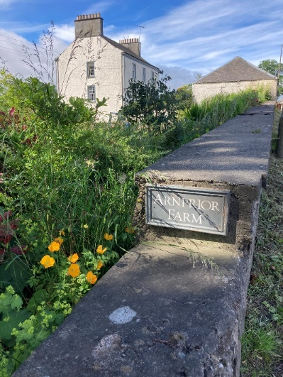
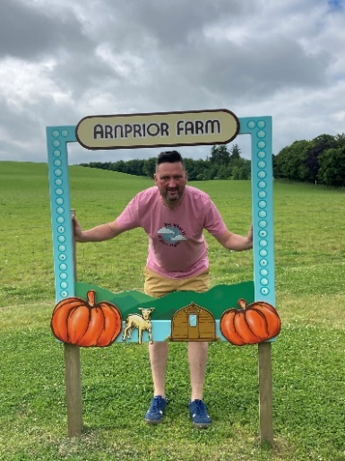

The Farm is Scotland’s original Pumpkin Farm, offers Glamping has an indoor swimming pool and offers farm experiences.
Duncan and Rebecca are the fourth generation of McEwen family to farm Arnprior and couldn’t be happier to be developing, diversity and enjoying their ‘time’ at Arnprior Farm. Together with their three children and the unwavering support of their parents they are intent on developing Arnprior to bring farming to life.
Arnprior Farm was established by Duncan’s family in 1936 and was primarily a beef, sheep and arable farm until 2015, when they decided to sell the cattle, increase sheep numbers, and try out diversification in the form of pumpkins. Some thought they were mad! Some still do! In five years, they have grown thousands of pumpkins and welcomed more than 1,500 people to their farm each year.
Duncan and Rebecca are proud when they became one of Scotland’s original and first pumpkin farms, they knew that Scotland was ready for pumpkins. Having suddenly become famous for pumpkins (something they never thought they would say!) they are delighted that we have become known for also creating unique interactive family farming days. They now offer not only the pick your own Pumpkins but also a lambing experience, dig for tatties and turnips experience, chainsaw carving and quadbike rides!
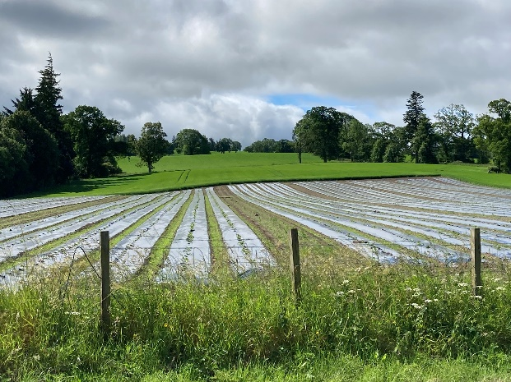
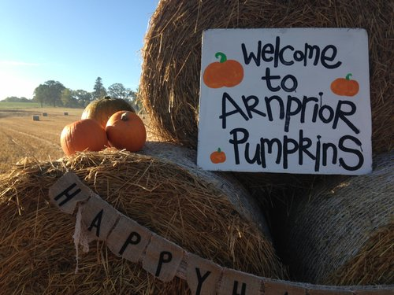

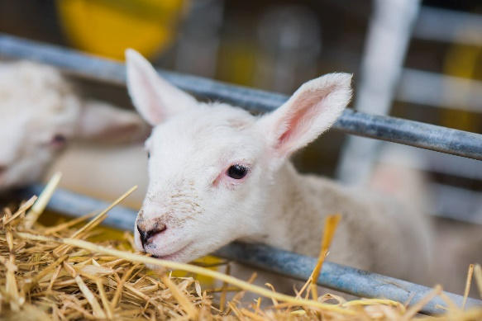
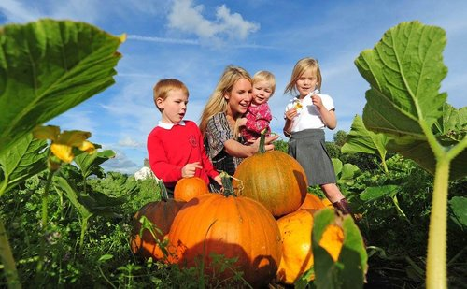
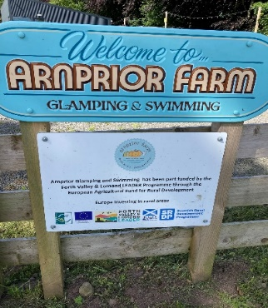
In 2019 they took a huge leap of faith (again!) and designed and built their own eco-friendly luxury glamping pod campsite. Complete with a bespoke private indoor swimming pool! The pool is a hive of activity with swimming lessons and pool parties each day and now employ a swimming instructor as part of the team at Arnprior
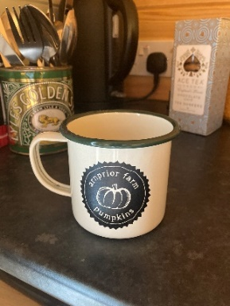
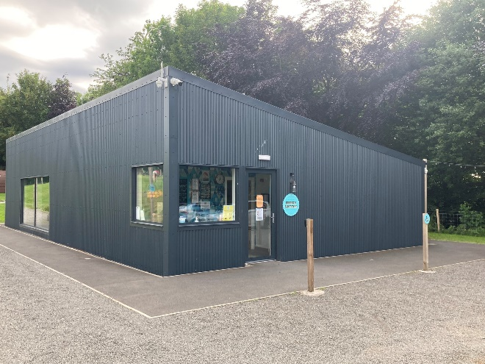
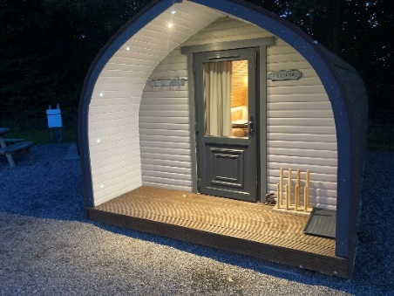
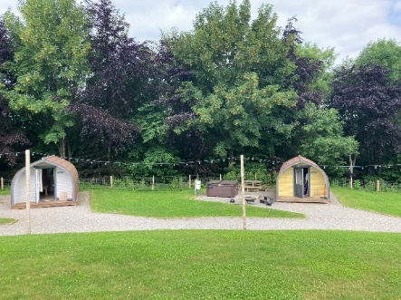

Arnprior is surrounded by the beauty and calm of the hills of Stirlingshire and close to Stirling for day trips and sightseeing so they knew that their farm was in the ideal spot for tourism too.

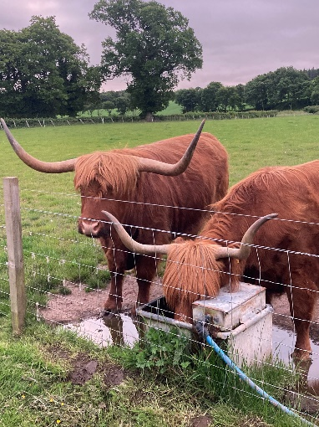

From lambing experiences in Spring to their famous pick your own pumpkin patch in Autumn, they are always busy! And with three children under 11 years old, 1,300 sheep, 800 acres of land and over 10,000 pumpkins to grow there’s always something to do….but they wouldn’t have it any other way.

Part 2 – Old Leckie Farm, Nr Stirling, Scotland

I identified Old Leckie Farm in Scotland as being different in its approach to farming and not only sells their own produce direct but offer the public the chance to visit and keen to engage with the public, yet able to manage this around the farming practices and a young family.
The family have won several awards namely Scotland’s Business & Product Innovation award and Farmers Weekly Diversification Award winners 2021

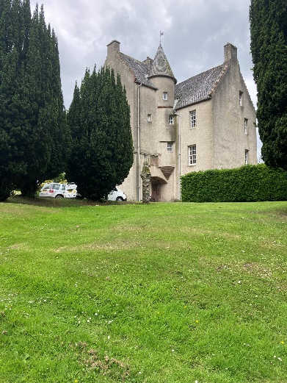

Nestled beneath the Gargunnock Hills, 7 miles west of Stirling, Old Leckie is surrounded by lush grass and age-old trees and has been run by the same family for over 100 years. A small 300-acre family farm they are proud to care sustainably for their animals and the environment so that they can grow the very best in fresh, local produce.
The farm has an online shop where you can purchase award-winning free-range eggs, grass fed meat and homegrown veg. If you’re a local customer they offer a weekly free home delivery service, or for those of you further afield they will organise a courier sending their popular meat boxes all over the UK. The family pride themselves in not mass production but providing a variety of products and services in turn providing several different income streams.
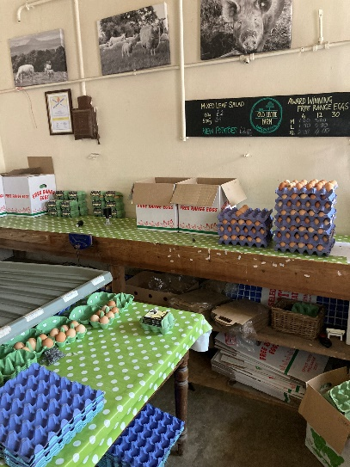
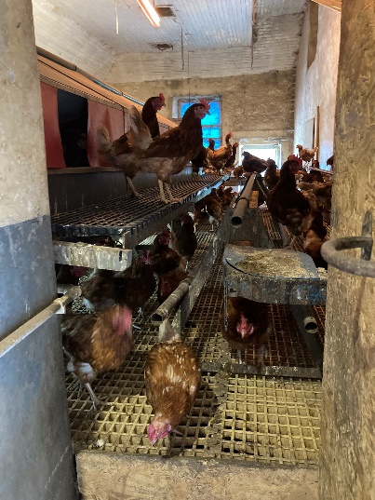

The farm offers five-star accommodation on site in one of the beautiful old farm buildings. The business was fortunate to receive some financial support to help set this up.
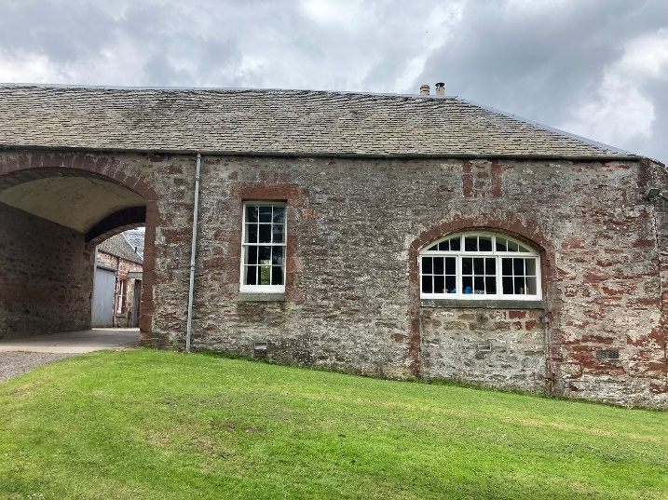

Farm visits are arranged on an individual basis and booked around farming jobs and family life. School visits are also encouraged, and the farm works closely with the Scottish organisation that links schools such as ‘farm to fork’ type projects.
This adding value model has created a more sustainable farming business less reliant on subsides. However not all attempts of diversification have been successful but being enthusiastic about not being afraid to give things a go and to maintain a sustainable business model for the future generations was a clear message from the family.

Part 3 – Iblei Mountains, Sicily

Albacara Farm describe themselves as young entrepreneurs with a long family tradition in agriculture. The company is in the heart of the Iblei Mountains and covers over 70 hectares between the Albacara and Carbonaro districts, straddling the provinces of Ragusa and Syracuse.
The land is described as fertile lands, uncontaminated and rich in biodiversity.
After being traditionally producing olives the siblings who inherited the farm from their grandparents decided to buy a herd of goats, which are now the pride of the company.
It is evident that the business has had substantial financial support from Europe, which enabled them to diversify and grow their business.
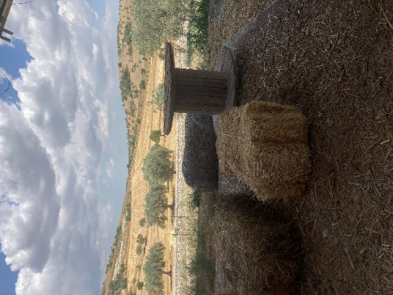
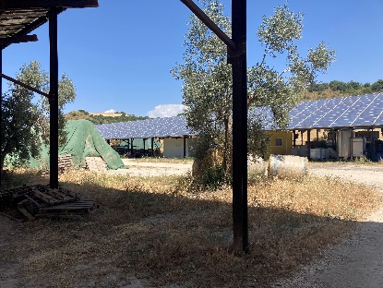
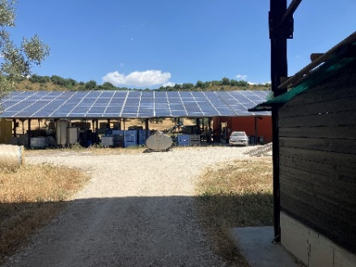

Currently they sell direct to the customer from the farm gate and to restaurants and supply outlets within Italy and abroad.
The farm produces a variety of goats cheese, yogurt, and milk along with 2 types of olive oil and wheat which they get made into pasta at a local pasta maker and packaged as the farm pasta.
The two types of olive oil that they produce and is recognised as one of the best you can buy, with numerous accolades. One is named after the grandfather and the other the grandmother whose business Albacara was. The olives are harvested, washed, pressed, and bottled all on site. No waste is what the business boasts, the pigs eat the remains of the olives after pressing along with the whey from making cheese!

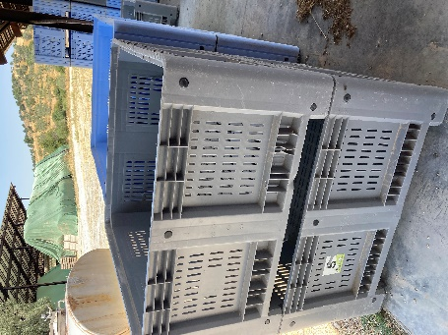
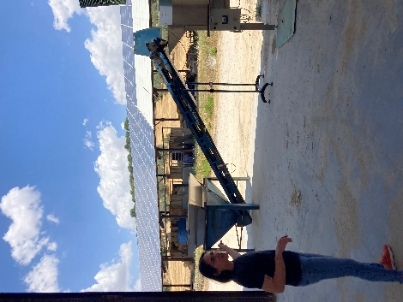
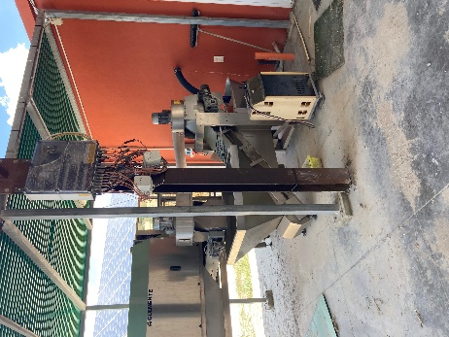

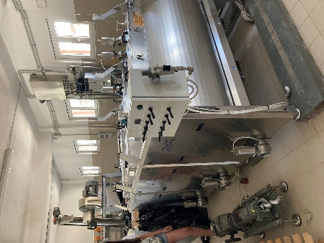
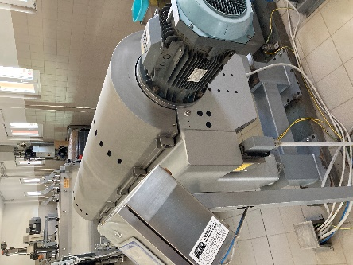
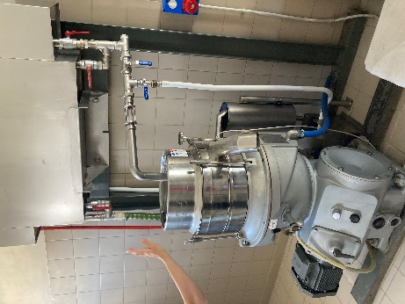

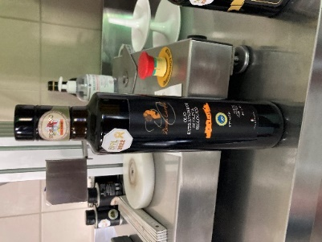
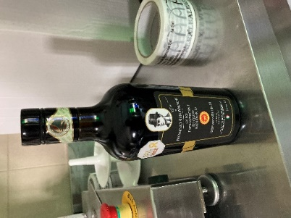
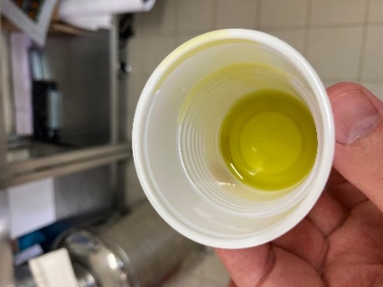

The farm currently has 150 goats that are milked twice a day. The farm did have more goats pre covid but had to sell some as a lot of their cheese is sold to fine restaurants, which obviously closed during the pandemic and had no market. However they have recently seen a big increase in demand and recently bought in a new breed of goat to add to the current type they keep,

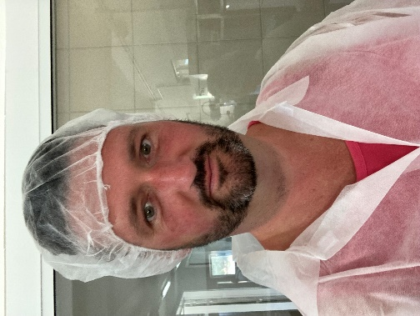
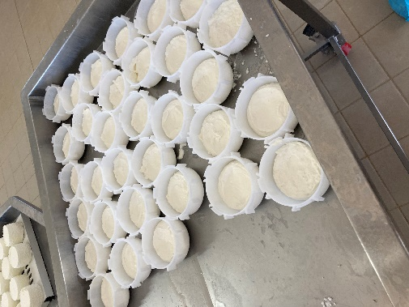
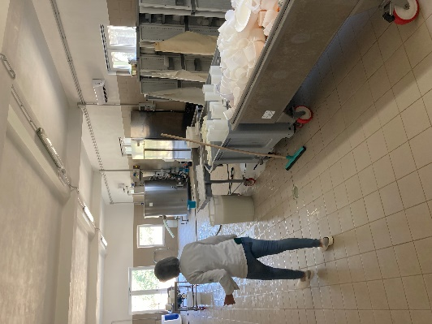
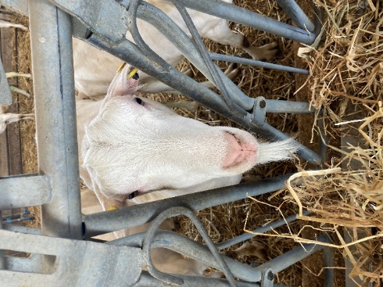
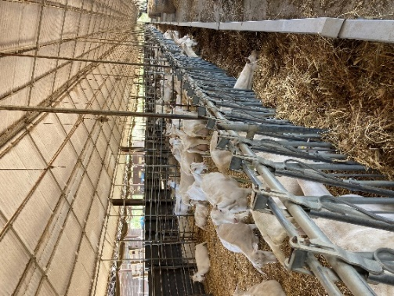
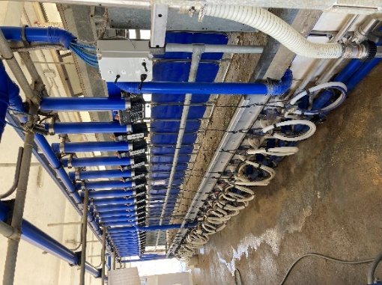
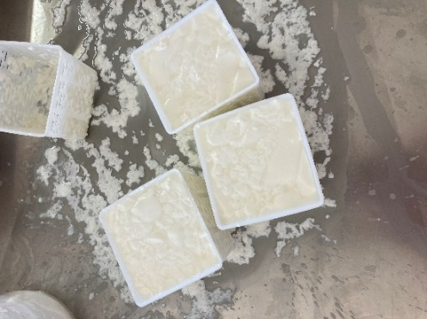
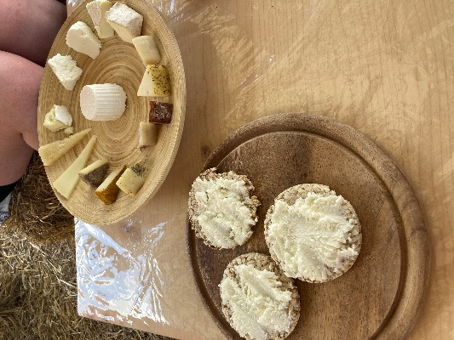
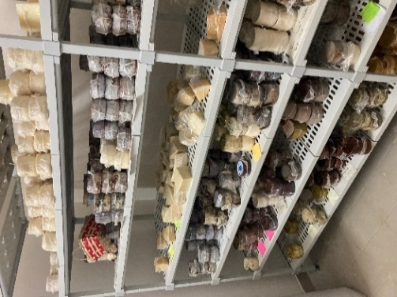

The farm hosts farm tours and cheese making experiences for individuals and groups. They are very passionate about the food they produce at Albacara and keen share this. They also offer a cheese lunch to those who attend a day, set out very rustically on straw bales.

Part 4 – Noto, Sicily

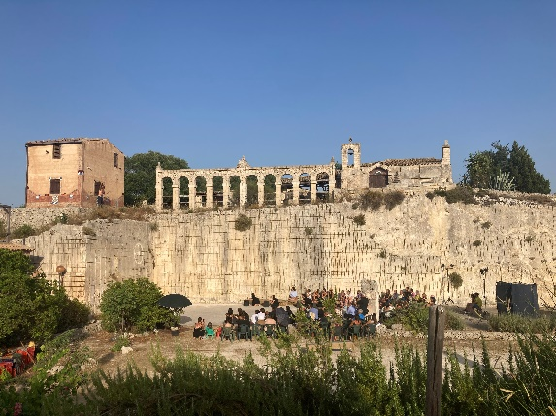
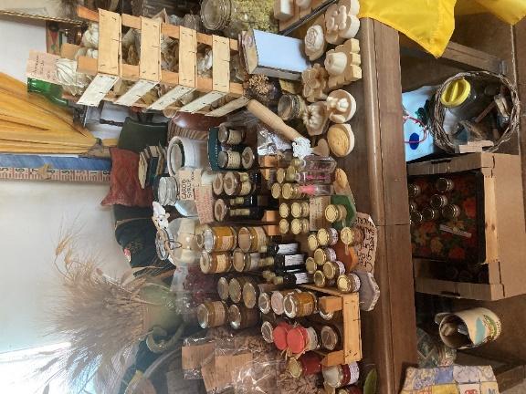
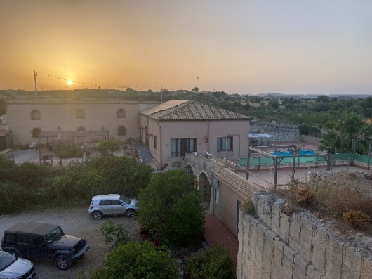
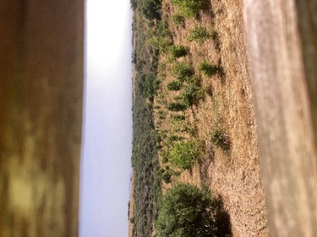
I identified Agriturismo Stallaini situated in the territory of Noto, Sicily as offering a unique experience to those who visit. It boasts a vineyard, olive groves, accommodation, restaurant, farm experiences and a unique venue for events within an ancient amphitheatre and disused quarry.

There is also an opportunity to buy foods they produce such as preserves, soap, lip balm to sundried tomatoes and pasta direct from the farm itself it is certainly a small family business with a difference!

Day One: After a meeting with the family business, I was keen to learn how the farm operates. It is very much a family business, with Manuela and her parents. Manuela is very much the face of the business and the first person you meet with a great welcome. Manuela is responsible for the social media, marketing, taking bookings and delivering the experiences. Manuela’s father is a self-taught chef and offers traditional Sicilian meals to those who visit for the day, attend experience or staying in one of the rooms.
I was fortunate to witness the farm being used as a venue for an outside Theatre during my stay. A visiting university theatre group from Milan gave a re-enactment of a ‘Greek Tragedy’ in the quarry/amphitheatre space with 100 in attendance. In traditional Sicilian style all who attended received a food and wine in a relaxed informal manner. Most of the food served was produced on farm or from the local area, something the farm was very proud of.
Day Two: I had a full tour of the farm and an explanation of its history and how the various aspects of the business have evolved. The business started as a small family vineyard and house before expanding and purchasing the olive grove next door. 10 years ago, the opportunity arose to buy the neighbouring disused quarry and amphitheatre with a few derelict buildings. People in the area thought they were mad! However, after some financial support from Europe and local Government they now boast a unique rural location offering food, accommodation and on farm experiences.
The farm also hosts an annual arts project, bringing sculptures and other artists together to enjoy the natural stone for carving. This has instigated numerous other artists of different mediums to use the site, enjoying the peaceful surroundings and hospitality. The site has art everywhere you look from carvings to tiles to wall hangings its most definitely unique!

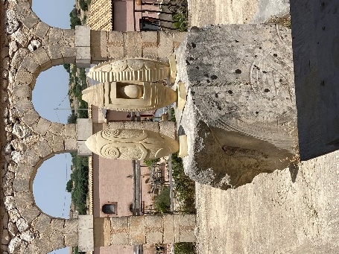
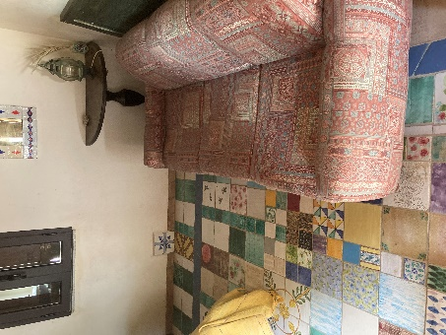
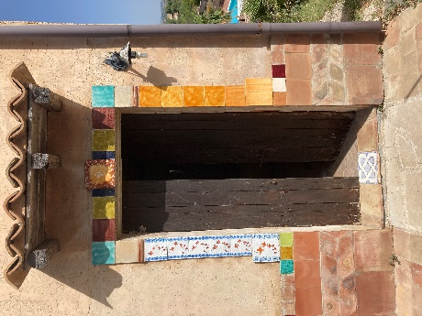

The farm has also been successful at taking part in a Biodiversity project by planting ancient fruit trees to preserve the environment for the future generations, again these are harvested, and food produced into items to sell and use in the business.

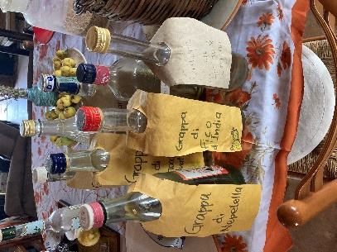
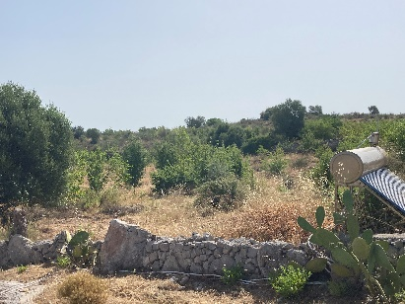
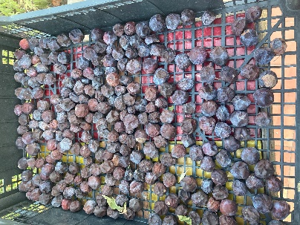

Day Three: Farm tour and pasta making experience.
The host Manuela has attended an Agri Chef funded course to enable her to being an ‘Agri Chef’ this was a short course to help producers to utilise the food they produce, turning the raw products into foods. Recently Manuela appeared on a popular Italian tv show demonstrating how to create dishes using tomatoes with the biggest tomato producer in Sicily. This support through training has also given Manuela the opportunity and confidence to deliver a farm tour, again something I was lucky to experience with other day visitors to the farm.
On an ‘experience’ you visit various aspects of the production at the farm before returning to the farmhouse to make pasta together. The session concluded with a lunch prepared by the group.
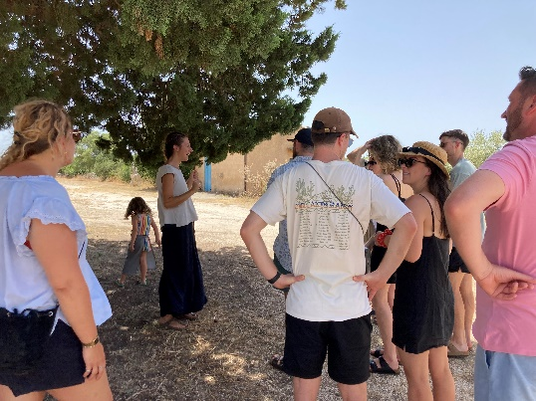
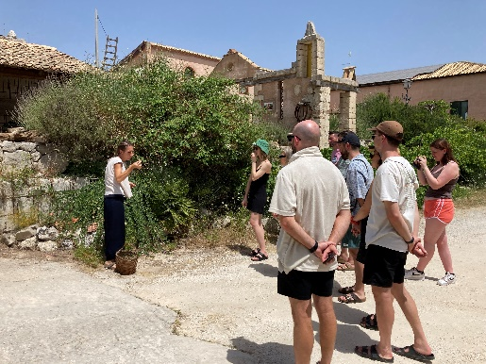
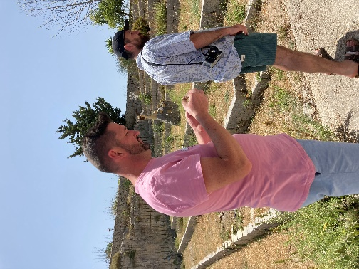
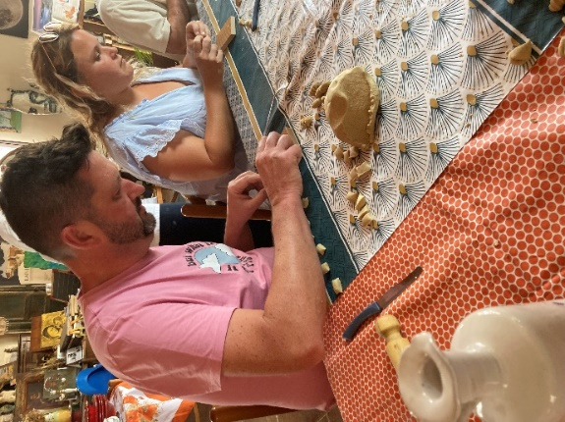
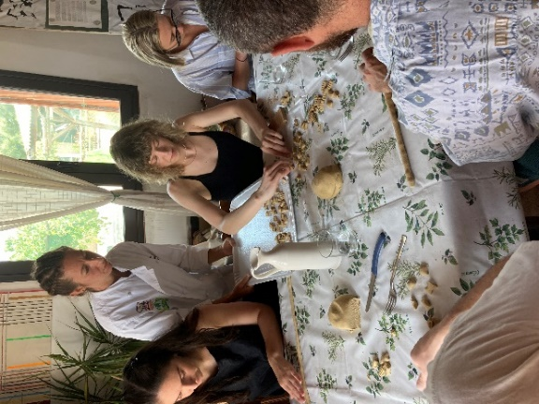
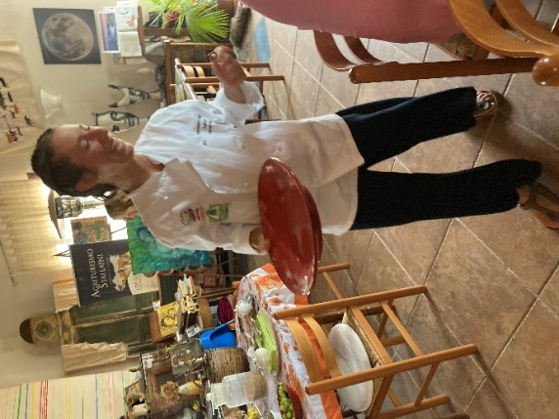
The session was enjoyed by all who attended and was both interesting and informative yet with an element of light hearted fun and enjoyment, making all feel very much welcome.

Next Steps
I would like to explore if there is any financial support and advice is available to develop the larger projects like those in Arnprior and Old Leckie as these are huge financial commitments to undertake without any support with investment and professional advice.
I am also keen to look at what I could offer on farm as an experience, using my own skills set and identify any gaps and again identify potential training opportunities and support required and available.
I would like to investigate what financial support and advice is available to develop food from ‘farm to fork’ and to add value to the products we produce.
I would also like to develop the accommodation side of the business whilst being mindful that being different and offering something unique is what is appealing to prospective customers.

Key Messages to the industry
- As an industry we need to consider promoting ourselves and the food we produce from the farm gate to maintain our unique identify as much as possible.
- Welcoming guests onto farm can create great interest, enthusiasm and most importantly an additional income
- Working collaboratively with other producers and organisations to maximise effectiveness
- Focus on the skills and interests you personally and family have for a diversity project to be a success.
- Having a unique selling point and being different will attract interest from prospective customers
- One successful diversification can take you in other directions
- Some farm diversification projects can take substantial investment and commitment
- Dare to be different!
- A diversification project can prove to be more profitable that the current farming practices and open other funding streams
- Customers like to know where food come from and like the story from ‘farm to fork’
- Skills such as cheese making are popular with those who have not done this
- Being able to produce products with the raw products we produce adds value
- Support through training is essential to develop skills set
- Consider what the next generation may like to be involved with

