**Innovation Advisory Council for Wales**

**Annual Review**

**Ian Menzies and Kellie Beirne**

**2016-2017**

Chairs’ foreword

The Innovation Advisory Council for Wales is in its third year of operation. As a Council whose members straddle the public services sector, business and industry, Higher Education and organisations such as NESTA and Innovate UK, we define innovation in a broad sense. We recognise that as a country we are impacted by problems that people experience in their daily lives: air quality, access to public services such as housing and transport, illnesses and health conditions and the accelerating impact of technology, automation and artificial intelligence.

Increasingly, we aim to better understand the dynamics and relationships across Science, Research and Innovation in order to solve complex problems – be they societal or industrial. As a result, our interests and work embraces government innovation; innovation-led economic growth; and, the engagement of civic society in responding to the big challenges of the day through social innovation. Innovation not only helps bring great ideas to life; it creates commercial and social value and promotes the human connections and relationships so key to building sustainability and resilience in our places.

We have worked extensively with the Reid Review of Research and Innovation in Wales because we recognise, post the UK’s departure from the EU, that we have to become more competitive and ambitious if we are to solve big problems, create new opportunities and attract the kind of new investment that sees us develop a keener sense of competitive advantage.

We have welcomed the creation of the new UK Research and Innovation (UKRI) and the Industrial Strategy because it chimes with our focus on ‘mission’-oriented thinking, providing a real opportunity to direct innovation in order to respond to the grand challenges of our time.  The opportunity as we see it is to direct economic growth in more meaningful ways and our launch of Arloesiadur, an innovation analytics dashboard that aligns economic geographies and value creation, provides a new platform to connect industrial strategy with innovation policy.

Our focus on public service innovation is maintained. Supporting Welsh Government with work on how we might refocus public procurement has enabled us to support Councils to secure SBRI projects in Wales. The wider opportunity is to embed circular economy principles in all aspects of procurement, which not only more closely embeds wellbeing goals, but takes a step closer to impact investing. As a collective we will continue to stretch thinking and be catalysts for a value added approach that stimulates the ambition, excitement and foresight that our country needs to thrive.

Ian Menzies and Kellie Beirne

*Co-chairs, Innovation Advisory Council for Wales*

 

Role and purpose

***“Innovation Wales - enabling business, inspiring society”***

The Innovation Advisory Council for Wales (IACW) was launched in October 2014 by the previous Economy Minister, and is made up of representatives from the public, higher education and business sectors, reflecting a wide range of stakeholders in the field of innovation.

The Council’s remit is to advise the Welsh Government and to raise Wales’ global profile on innovation matters. This will impact positively on the growth and sustainability of Wales’ economy, which in turn will improve the wealth and wellbeing of the people of Wales.

IACW provides information and advice to the Welsh Government. It aims to identify areas of existing strength and future opportunity, and scans for emerging trends and developments by using the EU’s Smart Specialisation[1] approach.

The Council is jointly chaired by Ian Menzies and Kellie Beirne, and has 10 further members.

Council members

* Mr. Ian Menzies (Joint Chair) - Managing Director, Northrop Grumman UK
* Ms. Kellie Beirne (Joint Chair) – Deputy Chief Executive, Monmouthshire County Council
* Prof. Sue Bale - Director, South East Wales Academic Health Science Partnership
* Ms. Jessica Jones – Engineer, Sony UK Technology Centre
* Mr. Andy Middleton - Founder Director, The Tyf Group
* Mr. David Notley - Impact Innovation
* Dr. Martin Rhisiart – Director, Centre for Research in Futures and Innovation, University of South Wales
* Mr. Steve Smith - Director, Technology Venture Investments, Development Bank of Wales
* Dr. Helen Swygart - Capability Improvement Manager, Qioptiq
* Mr Stian Westlake - Executive Director of Policy and Research, Nesta
* Dr David Wilkes - Deputy Director, Connect Portfolio, Innovate UK
* Prof. Robin Williams - Member of HEFCW committee and Chair, Science Advisory Council for Wales.

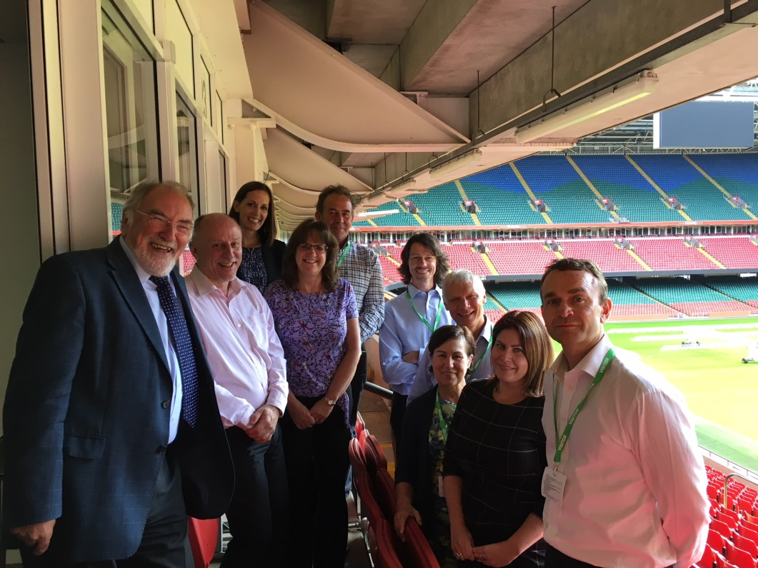

Themes



IACW has built its work programme around a set of priorities that emerged out of a planning exercise undertaken in its early days. These themes identified back in October 2014, served the Council well in terms of building momentum and providing a clear focus for activity. The themes identified in 2014 focused on:

* ***Public service innovation*** – to increase innovation in public service delivery, and give greater scope for business to generate innovative solutions for the public sector;
* ***International Collaboration*** – to improve Wales’ share of UK and European grant funding; to promote Wales as a connected and valued partner for collaborative innovation projects;
* ***Centres***– aims to increase R,D&I in Wales through developing and supporting applied research centres; help Innovate UK implement the Hauser Review[2] by identifying Welsh business and research strengths to grow these into real investment opportunities as future applied research centres;
* ***Measures and brand***– to understand the real level of innovation in Wales and develop better, real time measures for innovation and its impact.

Sub-groups were formed around the themes and success was achieved in relatively short timeframes.

Some of the themes achieved and delivered what they were set up to do. For example, much of the work in the measures subgroup is now encompassed within the Arloesiadur[3] project. Similarly, the Centres subgroup achieved success following Wales being awarded its first Catapult.

However, the focus of some of the themes has been superseded by wider policy developments, with new issues, proposals and opportunities arising. It was therefore felt that it was time to re-assess and re-focus the work of the Council and determine whether the original themes remained relevant or whether they should now be replaced by more pressing themes that matter most and can make the biggest difference.

It was decided the following themes will be taken forward:

* ***Public service-led innovation*** – to increase innovation in public service delivery, and give greater scope for business to generate innovative solutions for the public sector;
* ***Collaboration*** – to improve Wales’ share of UK and European grant funding; to promote Wales as a connected and valued partner for collaborative innovation projects; and to promote collaboration across sectors within Wales. The focus will be on international partnerships and forming relationships. It should not just be about local collaboration within the nation/region, but about global collaboration;
* ***Wellbeing of future generations*** – to look at the trends and patterns that will influence how we live, work and learn in a future Wales; looking ahead to understand what’s important to people and communities in the next 30 years and what impact the next 30 years have on the way we live, work and learn;
* ***National Innovation Body (NIB)*** – to build upon the potential identified for a new NIB and provide a detailed analysis of the scope and potential that exists to establish an entity capable of driving innovation and creativity across public and private sectors; hoping it will provide better alignment for the innovation landscape in Wales.

The year in summary

The Council has now held 12 plenary meetings to date, and members have been involved in specific work groups, focussing on the four themes.

**Additional activity included**:

* providing advice to WEFO on potential EU-funded projects;
* submitting written evidence on the Reid/Hazlekorn Review into Post Compulsory Education and Training in Wales; and updating Professor Reid on the work of the Council;
* welcoming Dr Ruth McKernan, Chief Executive of Innovate UK to an IACW meeting who provided Council with an update on the Industrial Strategy Challenge Fund (ISCF);
* welcoming the Minister for Skills and Science to an IACW meeting;
* regularly attended meetings with the Minister for Skills and Science to update her on progress and work of the Council;
* partaking in a telephone interview with the Interreg Manumix project team to provide information about IACW, how it was formed and established, its membership, its governance arrangements, how it interacts with government, Council successes and a discussion on the governance of innovation policy in Wales;
* hosting the Chief Scientific Adviser for Wales at an IACW dinner to encourage a closer working relationship with the Science department.

**Significant milestones for IACW in 2016/17 include**:

* Re-evaluation and identification of new key themes;
* Continue to work with the Welsh European Funding Office (WEFO) to determine the strategic fit of potential European projects with a Welsh Innovation agenda. This has recently included a call for innovative proposals that can successfully translate research and innovation into new and improved commercial products, processes and services. £40 million of ERDF was made available for proposals that included a strong industrial pull.

**The Innovation Summit**

The IACW’s first Innovation Summit was held in September 2016, attracting over 120 attendees. It ran alongside Venturefest at the SWALEC Stadium and focused on public service innovation. The agenda featured:

* A business breakfast discussion on Innovation in the City Deal;
* An interactive session on the possible establishment of a NIB;
* A keynote speech from The Minister, Julie James on encouraging the use of innovation in the public sector;
* Y Lab ran a challenge workshop on solutions to public sector challenges;
* and Nesta discussed future trends and technological breakthroughs.

**NIB Update**

The previous work undertaken by the Council into the possible establishment of a NIB for Wales included:

* producing an initial scoping report to examine the role of National Innovation Bodies in supporting regional economies. This was written by Nesta and Cardiff University;
* holding stakeholder engagement workshops to solicit views and support from key individuals from business, academia and cross government on the concept of a NIB; and
* a report was submitted by IACW for the Ministers consideration highlighting the viewpoints from the stakeholder workshops. The report included a number of recommendations and options for the formulation of a NIB.

The previous Minister for the Economy and the current Minister for Science and Skills approved the joint IACW/WG report in 2016 and recommended that further work be commissioned by external consultants to look at the budgetary and financial implications and the arrangements, scope of operation, and governance models.

Consultancy agency CM International was commissioned to produce the business plan and examine if there was a role for a NIB in Wales. It considered in much more detail, in liaison with stakeholders, how such a body would relate to the existing UK and Welsh innovation support system.

The report was submitted to the IACW in early 2017, who support the findings of the report and the evidence base. The IACW believe the idea of a dedicated body could help drive forward Wales’ national innovation performance and will help accelerate progress within existing and emerging industry clusters, as well as within social and public sector innovation.

**Arloesiadur**

The commissioning of *Arloesiadur: An Innovation Dashboard for Wales[4]* project in collaboration with Nesta.

Arloesiadur aims to capture and measure innovation in real time, using new sources of data. It uses big data to measure and visualise the innovation landscape in the technology, research and industry sectors, by using a range of data sets from the Office of National Statistics, open data published by Research Councils and Innovate UK, and web data from Meetup, an event platform.

Arloesiadur has been created to help policy makers and economists that often rely on once-yearly official surveys which are organised in ways that make it very difficult to study new industries and technologies, with more accurate and timely evidence upon which to base the policies to drive growth.

The Dashboard is now live and can be found at <https://arloesiadur.org/>

**UKIS**

A successful negotiation with the **UK Department of Business, Innovation and Skills,** for more Welsh business representation in its UK Innovation Survey (UKIS).

The UKIS provides a means to measuring the level, types and trends in innovation activity and behaviour among businesses within each of the regions of the UK. The data contributes to the understanding of the constraining factors faced by businesses, across various sectors and size classifications, to innovate, and provides the empirical evidence to support policy measures.

The Innovation Advisory Council for Wales, believe an increase in the sample number of Welsh companies surveyed will help Wales gain a better understanding of innovation in the key sectors in Wales.

An increase has been requested to achieve a sample size of 2,000 businesses, with the aim of receiving 1,000 responses. Wales targeted 1,600 businesses in the 2015 survey, and so are looking to boost the sample by 400 businesses.

This will result in a truer snapshot of the state of innovation among Welsh businesses. Work to start the increase in the number of companies surveyed commenced in January 2017.

Forward Looking

Since its launch in October 2014, the Innovation Advisory Council for Wales has made significant progress.

At the request of the Cabinet Secretary, a review into external advisory bodies providing advice to Ministers is taking place. The results of this review have not yet been released.

The IACW is awaiting the outcomes of the Reid and Hazlekorn reviews before concluding and submitting the findings of the commissioned report on a possible establishment of a NIB in Wales to the Minister for Science and Skills.

1. <http://s3platform.jrc.ec.europa.eu/ris3-guide>
2. <https://www.gov.uk/government/publications/catapult-centres-hauser-review-recommendations>
3. <https://www.nesta.org.uk/blog/arloesiadur-innovation-dashboard-wales>
4. <https://arloesiadur.org/>