SPACE IN WALES CAPABILITY MATRIX
Company Name:
Company Address:
Website:
Phone Number:
Contact Email:
Logo jpeg
Company Overview: (background, T/O, Employees no.s etc.)
Max 200 words
Company Capabilities:
Max 200 words
Currently Operating in Sectors:  (Tick all that apply) | ☐ Space  ☐ Defence  ☐ Aerospace & Aviation  ☐ Automotive  ☐ Health  ☐ Agriculture  ☐ Media  ☐ Energy  ☐ Maritime  ☐ Transport & Logistics | ☐ Tech – Software/Hardware  ☐ Infrastructure & Smart Cities  ☐ Safety & Security  ☐ Mining  ☐ Environmental  ☐ Internet of Things  ☐ AI & Big Data  ☐ Finance  ☐ Education  ☐ Tourism
Any Space Related
Products & Services:
(e.g. Use of Satellite Earth Observation data, satellite navigation, satellite communications)
Space Related Projects Worked On:
Which Space related Products and Services do you offer  (Tick all that apply) | ☐ Launch Services  ☐ Launch Vehicle Manufacturing and Assembly  ☐ Component and Subsystem Manufacturing  ☐ Launch Support Services  ☐ Ground Segment Subsystem & Equipment Supplier  ☐ Antenna/Ground Station Component or Material Supplier  ☐ System Engineering and Technical Support Services  ☐ Ground Station/Teleport Owner/Operator  ☐ Tracking, Telemetry & Command Operations  ☐ Satellite Manufacture  ☐ Navigation  ☐ Observation Imagery  ☐ Robotics  ☐ Satellite Communication  ☐ Satellite Operation  ☐ Satellite Positioning  ☐ Satellite Software  ☐ Space Data Collection  ☐ Space Security  ☐ Space Research  ☐ Telecommunications  ☐ Weather Forecasting  ☐ Other – Please specify
Which Satellite Applications are used in your Products and Services?  (Tick all that apply) | ☐ Satellite Positioning, Navigation and Timing  ☐ Satellite Earth Observation Imagery  ☐ Satellite Telecommunications  ☐ Microgravity Services  ☐ Other – Please specify
Support Services:  (Tick all that apply) | ☐ Legal Services  ☐ Financial Services  ☐ Insurance Services  ☐ Consultancy Services
Which Innovative Technologies are you interested/involved in?  (Tick all that apply) | ☐ AI and Machine Learning  ☐ 5G Communications  ☐ Virtual Reality  ☐ Internet of Things  ☐ Cybersecurity  ☐ Blockchain  ☐ Other (please specify)
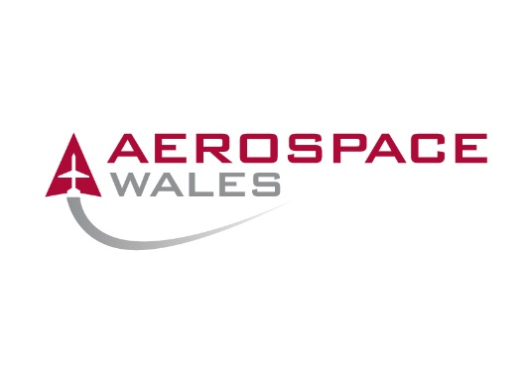 | PLEASE RETURN COMPLETED FORM TO:  rachael@aerospacewales.aero and  lucy@ellisonmarketing.co.uk

