W e l s h G o v e r n m e n t
F u t u r e P r o o f i n g F u n d

Webinar, delivered by Shayne Yates

I n t r o d u c t i o n s
- Aims for today’s session.

- Questions, please keep to the end or add to the chat facility if related to a proposed project idea.

- Please ensure any questions asked at the end are only related to the eligibility/criteria of the fund only.

- Virtual Observations-:

- Please mute your microphones.

- Please take notes.

- Session freezes, log back in.

- Virtual safety considerations.

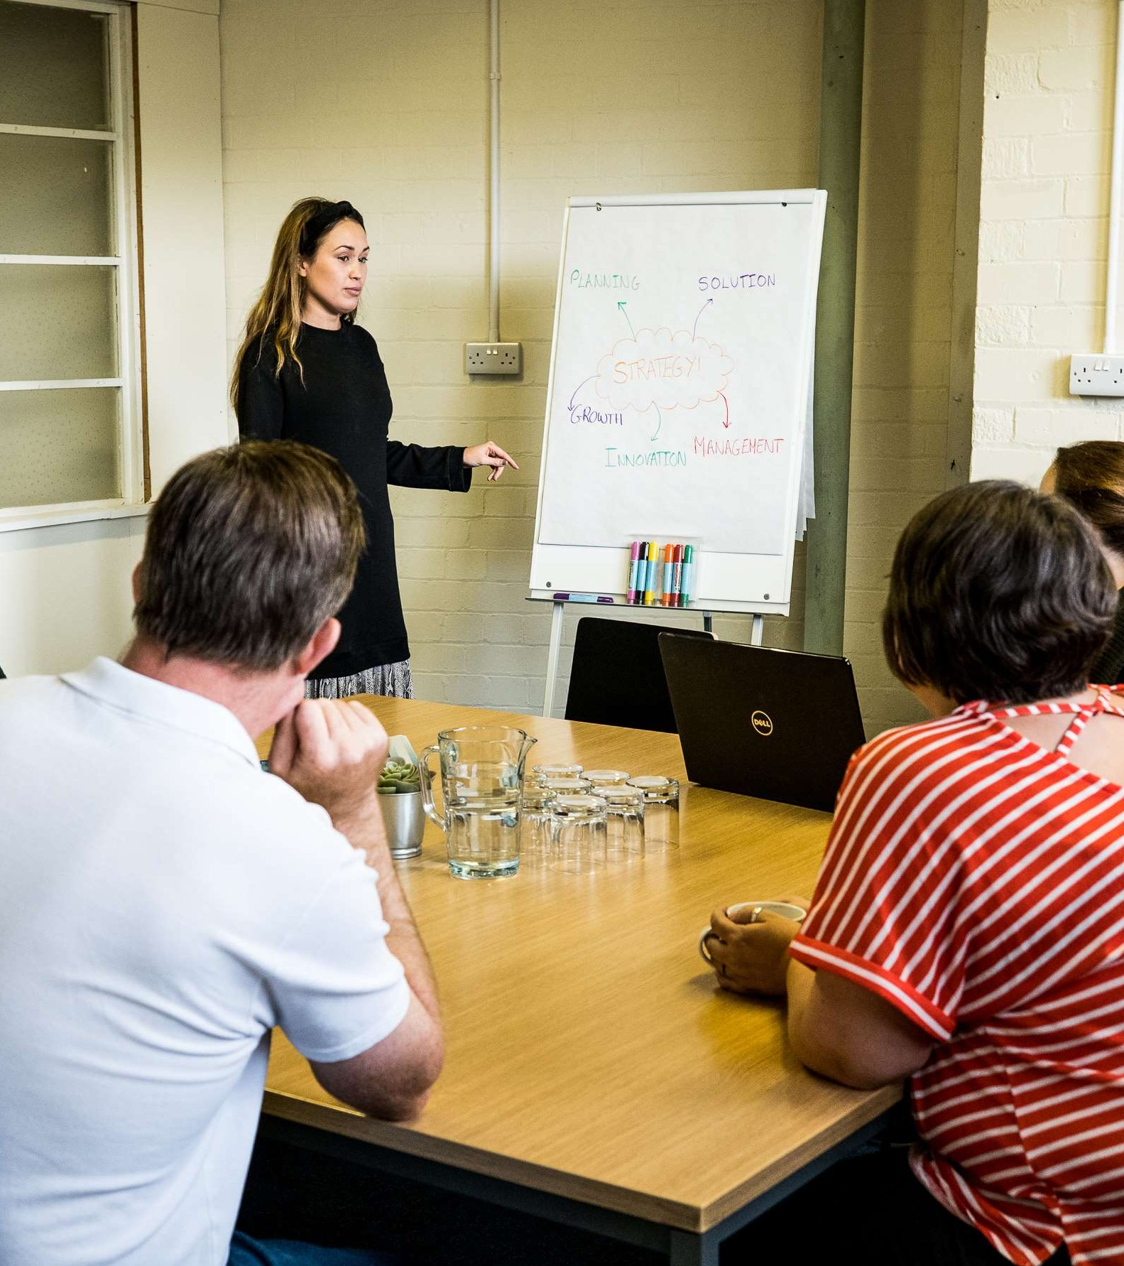

S e s s i o n O v e r v i e w

- What is the Future Proofing Fund?.

- Intervention Rate.

- Eligibility Checker.
https://businesswales.gov.wales/future-proofing-fund

- Application Requirements.

F u t u r e P r o o f i n g F u n d

About the Fund-:

Key sectors-:
- Retail.
- Hospitality.
- Leisure.

Support Dependant on Project Costs-:
- Minimum 5K to Maximum £10K.
- Grant can't exceed 75%.
- A 25% contribution will be required.

Eligibility Checker-: Live 18th April
- https://businesswales.gov.wales/future-proofing-fund

Application Requirements Next

W h o C a n A p p l y

The Welsh Government Future Proofing Fund is open to “Eligible”
businesses (See eligibility checker)
- Retail.
- Hospitality.
- Leisure.

- Micro businesses employing between 1-9 employees.
- Small businesses employing between 10-49 employees.
- Medium sized businesses employing between 50-249 employees.

This grant can only be claimed by Sole Traders/Partnerships or Limited companies that meet the following criteria:

- Projects cannot start prior to approval of funding
- Business location.
- Eligible sectors.
- Operate from a property.
- Business rates.
- Must have been trading before 1st April 2023.
- VAT registered if turnover exceeds £90K or sector exempt.

S o l e T r a d e r / P a r t n e r s h i p s C r i t e r i a

  - You must pay employees via PAYE as of 1st April 2024.

  - If you only employ 1 person this can be the business owner, but they must be paid via PAYE.

  - Please note the 1 employee must be a Full Time Equivalent (FTE) and work at least 30 hours per week. This can be made up of part time staff but must equal to at least 1 FTE
i.e. the total hours regularly worked by part time employees must equate to 30 hours or more per week.

  - Zero-hour contracts Welsh Government position, if being used, please confirm in your application they are by mutual agreement.

L i m i t e d C o m p a n y C r i t e r i a

  - You are a Limited company as of the 1st April 2024.

  - Employing between 1 and 249 employees via PAYE as of 1st April 2024.

  - If you only employ 1 person this can be the business owner, but they must be paid via PAYE.

  - Please note the 1 employee must be a Full Time Equivalent (FTE) and work at least 30 hours per week. This can be made up of part time staff but must equal to at least 1 FTE
i.e. the total hours regularly worked by part time employees must equate to 30 hours or more per week.

  - Zero-hour contracts Welsh Government position, if being used, please confirm in your application they are by mutual agreement.

O t h e r F u n d C r i t e r i a
- Social enterprises.

- No revenue items permitted.

- Claim submission timelines.

- One application per business.

- Multiple businesses limited to x 2 applications.

- Activities not supported.

- Supported businesses, timelines of trade and jobs.

- Applications must be submitted by the business owner.

- Planning permissions.

- Franchises.

- Carbon footprint considerations.

- Staff redundancies.

W h a t I t C a n ' t S u p p o r t

- Funding operational running costs (e.g. utilities, rent, stock purchase).

- Pay off existing debt.

- Subsidising wages or any staff costs.

- Any purchases made before an award from this grant application.

- In kind funding. In-kind funding usually refers to non-monetary contributions and support from other sources.

- Redundancy costs.

P r o j e c t E x a m p l e s

As part of the application, applicants must demonstrate by way of detailed, clear narrative and planned activities,

  - How their proposed project invests in measures to future proof their business.

  - This could be through cost savings, increased revenue and/or profit, or by reducing the percentage of fixed costs impacting the business.

  - This information will be used to score your application and the highest scoring applications will receive an offer of funding if they meet all other criteria.

E x a m p l e 1

Example 1:

A gift shop occupying a premises with a rateable value of £12,000 with a full-time owner and 2 part-time employees working 18 hours each paid via PAYE, planning to undertake a renovation project to increase revenue by improving the storefront to be more visually appealing for promotion of goods and for the building to be more energy efficient.

Project to include replacement of rotten wood surround frontage and single aluminium window and door, with a new insulated brick structure and double-glazed window and door, construction of wooden en-cased window retail display for promotion of locally made Welsh products.

The company brings in a local building firm to revamp the front of the store and construct the new display area.
Expected uplift in profit of £300 per month (£3,600 per year), with project investment return of £10,200 within 34 months.
Total eligible project cost: £10,000.
Welsh Government Grant for capital purchases £7,500. Applicant contribution for labour & surplus capital costs £2,500.

E x a m p l e 2

Example 2:

A busy café attached to an adventure attraction who operate and own the premises with a rateable value of £30,000 that has high energy running costs and employs 4 full-time and 6 part-time staff working 15 hours each per week paid via PAYE.

Project is to install solar panels with battery storage to reduce energy bills and install self-serve ticketing at entrance. One job safeguarded as ticketing personnel redeployed in the adventure side of the business. Expected return of project costs (£30,000) to the business within 27 months via reduction in energy costs of
£2,000 p/month during season.

Total project cost: £30,000.
Welsh Government Grant towards capital purchases £10,000. Applicant contribution for installation & surplus capital costs
£20,000.

E x a m p l e 3

Example 3:

A popular local gastro pub with 3 x 4* bedrooms, and a rateable value of £40,000 who employ 20 FTE staff working a variety of hours via PAYE.

Project is to bring forward redevelopment of final 4th bedroom, improve landscaping around the premises and car park to allow them to harvest rainwater for re-use in toilet cisterns and install 2 electric charging points. 1 job created.

Project would see higher quality offer to attract more customers/increased spend projected to be £25,000 per year from additional bedroom.

Project costs expected to be recovered within 2 years. Total project cost: £20,000.
Welsh Government Grant for capital purchases/building £10,000. Applicant contribution for installation & surplus capital costs
£10,000.

K e y A p p l i c a t i o n R e q u i r e m e n t s
Your Next Steps “Online Application”

H o w t o A p p l y

The Future Proofing Fund will open to applications in mid-May, but the on-line fund eligibility checker will open from week commencing 15th April 2024.

The fund will close 3 weeks after it opens or when the budget for the fund had been allocated, whichever is the sooner.

All applications submitted will be processed in ‘date received’ order, but applicants should note that applications with incomplete or incorrect data or those missing the required supporting documentation may be rejected.

Rejected applications where missing or incorrect information are identified as the issue, can be re-submitted as long as the application window remains open. Re-submissions will not be accepted after the application window closes.

S u p p o r t i n g
D o c u m e n t a t i o n

- Applicants will be required to submit the following information by email and within 1 working day of their application submission, to FutureProofingFund@gov.wales

- Quoting their unique application reference number, which will be confirmed on screen once the application has been submitted successfully (please make sure you keep a note of this number):

- At least 2 quotes for each piece of capital purchase or other costs associated with the delivery of your project.

- Evidence of your match funding proportion by way of bank statement and/or loan agreement paperwork.

- Copy of your non-domestic rates invoice from your local authority.

- Bank statements for the previous 3 months to verify that the business is actively trading and as evidence of sufficient cashflow.

P e r s o n a l D e t a i l s

- Please confirm that you are an authorised signatory of the business.

- Title, first name, last name.

- Email address, telephone number.

- Position in business.

- Demographic information could be requested.

A b o u t Y o u r O r g a n i s a t i o n

  - Business trading name.

  - Business registered name.

  - Email address, telephone number, website.

  - Business address and business registered address if different.

  - In what capacity are you applying? Dropdown list: sole trader, partnership, limited company, LLP, PLC, charity/social enterprise, special purpose vehicle.

  - I confirm my business is located, operating and employing staff in Wales.

  - VAT number.

A b o u t Y o u r O r g a n i s a t i o n

  - Company Registration Number.

  - Charity number.

  - Please confirm you employ people using PAYE?.

  - Please identify primary sector for your organisation by selecting the most appropriate category from the drop-down list: retail, hospitality, leisure.

  - Annual Turnover (in your most recent annual accounts).

  - Number of Employees (Headcount) - In Post.

  - Number of Employees - Full Time Equivalent.

P r o j e c t I n f o r m a t i o n

There is a 20-minute time limit per section

In advance of accessing the application and completing, please consider what information you will need to provide.

Please ensure you complete free text sections by typing directly into the fields. Do not copy and paste text from Word documents as not all characters are recognised. Applicants can copy & paste from other text editors such as Notepad.

This is a competitive grant and therefore each section completed, will be scored against the viability and impact of your project.

P r o j e c t I n f o r m a t i o n

    - Project start date - Project end date. A project cannot start prior to approval of funding.

    - Please describe your project “What, Why, Where & When”.

- What is the project, provide a full description, remember we
don’t know anything about you, your team, or your business.

- Why are you looking to implement the project and level of investment required, based on what grounds? provide examples.

- Where in the business will the proposed project be aligned? how will this investment support and grow this aspect of your business model? provide examples.

- When will the project be implemented, timelines and results through to completion? provide examples.

P r o j e c t I n f o r m a t i o n

- Understand the grant requirements. From the funding organisation’s goals to application deadlines – it is essential to understand the grant requirements and guidelines thoroughly.

- Develop a compelling narrative. A successful grant proposal should tell a story that captures the funder’s interest and demonstrates the significance of the proposed project.

- Demonstrate impact. Funders want to know how their investment will make a difference. To make a strong case, grant applicants should demonstrate the potential impact of their project and provide specific examples of how it will benefit the target audience or community.

- Be sure to have a strong understanding of your project-: Include desired outcomes, estimated timelines, and other funding sources.

P r o j e c t I n f o r m a t i o n

    - This project will help future proof the organisation by: (please select either)

- Reducing fixed costs.

- Increasing revenue or turnover.

- Realising cost savings.

- Safeguarding jobs.

- Creating new jobs.

- This is a competitive grant and therefore this section is a very important part of the application, as we will use the information you provide to score the viability and impact of your project.

P r o j e c t I n f o r m a t i o n

    - Please outline the benefits of the project and describe how this will improve the organisation.

Here you could include the following-:

- Where the business was pre project investment, challenges faced, costs incurred, sales held back, competition advancing, these are an example of what could be included.

- Confirm how the project will benefit the business for the short- long term future, what areas in the business will benefit from the investment and why? provide examples.

- Confirm how the proposed project will further improve the wider organisation, this potentially paving the way for further increased investment in the future, what aspects will benefit? provide examples.

P r o j e c t I n f o r m a t i o n

    - Project risks/challenges

Here you could include the following-:

- Pre project, risks and challenges faced, provide examples.

- Risks and challenges identified across the project timeline, impact on current business delivery, provide examples.

- Risks and challenges aligned towards future trading, if the project doesn’t go ahead or investment secured, again this providing balance aligned towards your project plan, provide examples.

P r o j e c t I n f o r m a t i o n

Project resources and management Here you could include the following-:
- Pre project impact on current resources and management, provide examples.

- How you propose to utilise current resources and management to see through the project, what skill sets do they have, how this may impact current performance or increase focus towards the long-term objectives of the organisation, provide examples.

- Post investment, provide an overview of how the investment will strengthen the resources and management of the organisation, this providing examples aligned towards pre and post investment.

E c o n o m i c C o n t r a c t

- What is the Economic Contract.

- There are x 4 Pledges, how does your business align to x2+.
- Fair Work.
- Promotion of Wellbeing.
- Low Carbon.
- Climate Resilience.

- Fair work practices and requirement for further information.

- Link for further support-: https://businesswales.gov.wales/economic- contract

E m p l o y m e n t I n f o r m a t i o n

- Please complete the jobs table:
- Job role.
- Basic salary.
- Number of full-time jobs.
- Number of part time jobs.
- Dropdown job created, or job safeguarded.

P r o j e c t C o s t s

Complete eligible project costs table:

  - New equipment purchase.

  - Upgrades to existing systems or machinery.

  - other (specify).

P r o j e c t F u n d i n g

  - Complete table:
    - Bank Loan.
    - Directors’ loan.
    - Company own funds.
    - Overdraft.
    - Other.

  - How much grant are you applying for?

D e c l a r a t i o n s
It is very important that you have read this guidance document and understand the terms and conditions associated with this Grant application as this forms part of the contract between you and the Welsh Government.

A p p l i c a t i o n S c o r i n g

As this is a competitive grant, each application will be scored against the following criteria and award offers will only be made to the highest scoring applicants.

  - Project viability & delivery plan.

  - The impact of the project on the business.

  - Fair Work.

  - Economic Contract Pledges.

N e x t S t e p s

- Check your business/organisation is eligible to apply via accessing the Eligibility Checker, this can be found on the Business Wales website https://businesswales.gov.wales/future- proofing-fund

- If eligible, please progress to complete your online application form as soon as possible, expected to open mid-May, please following the guidance document which is also available online-: https://businesswales.gov.wales/welsh- government-future-proofing-fund-guidance

A n y F u n d C r i t e r i a Q u e s t i o n s

I will be unable to answer any specific questions aligned to your proposed project, any questions asked which are aligned to a proposed project can be included in the chat facility, these will be shared with Welsh Government.

