Draft Text for Foundational Economy Web Pages Based on Fair Work for Wales | Business Wales

(Landing Page)
Supporting the Foundational Economy in Wales
A thriving foundational economy is essential for a resilient and prosperous Wales. The foundational economy encompasses the everyday goods and services we all rely on, spanning sectors such as care and health, food, housing, energy, construction, transport, retail, and tourism. Business Wales is here to support your business within these essential sectors, providing resources to help foster innovation and sustainability.
With 60% of Welsh businesses and over half the workforce involved in the foundational economy, this sector is vital for a thriving, resilient Wales. By building on foundational principles, your business can not only expand but also contribute to long-term economic stability.
Why Focus on the Foundational Economy?
The foundational economy central to Wales’ economic strategy, as it represents 47% of total business turnover in Wales. It also addresses big challenges that affect us all, like tackling the climate crisis, creating local jobs, developing skills for the future, and building strong digital and transport infrastructure. Plus, it plays a big role in building a resilient food system and strengthening local supply chains, which are key to supporting Wales’ economy and environment.
Business Wales, in collaboration with foundational economy experts, provides sector-specific support to help businesses excel in these areas. Our initiatives include fostering local supply chains through "Meet the Buyers" events, aligning with the Well-being of Future Generations Act 2015, and supporting food supply improvements within the public sector. By participating, your business can access tailored resources to grow and make a positive impact on the Welsh economy.

IN THIS SECTION

Supporting Local Supply Chains

Supporting Food Supply in the Public Sector

The Foundational Economy and the Wellbeing of Future Generations

Social Partnership Public Procurement Act & The New UKG Procurement Act

Support and Guidance for Joint-Bidding

(Above Tiles Link to Sub Pages)

The Foundational Economy and the Wellbeing of Future Generations
A strong foundational economy is key to a resilient, prosperous Wales. This economy covers the essential goods and services we rely on every day—spanning care and health, food, housing, energy, construction, transport, retail, and tourism. Through support aligned with the Well-being of Future Generations Act 2015, Business Wales works to promote economic growth, environmental resilience, health, equality, and cultural richness across these vital sectors.
Discover how your business can actively contribute to these goals, helping build a fairer, greener, and more resilient Wales for generations to come. Discover how the Well-being of Future Generations Act can guide positive change for businesses across Wales below.

THOUGHT LEADERSHIP VIDEOS
What is the Foundational Economy?
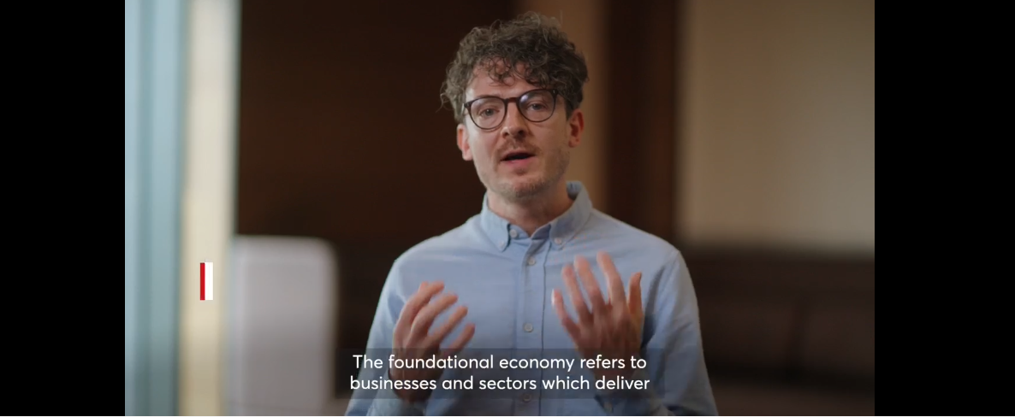
The Wellbeing of Future Generations Toolkit from a Foundational Economy Perspective
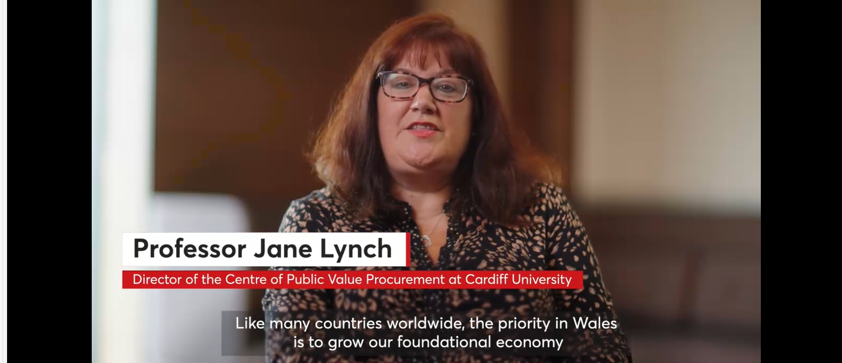
RESOURCES
Report on the Wellbeing of Future Generations Act and it’s impact on SMEs
Explainer Infographic

Supporting Local Supply Chains
Are you an SME or business owner looking to grow by tapping into new markets? Supporting local supply chains is key to strengthening the Welsh economy, and your business could be a vital part of it. Business Wales, in partnership with the Welsh Government's Foundational Economy team, has been working to help connect businesses with local opportunities.
Through initiatives like Business Wales expos and "Meet the Buyer" events, we bring some of Wales' biggest buyers directly to you. The Business Wales Expos featured a host of live contract opportunities—over £36 billion from over 90 major buyers. With over 800 attendees, these events are a powerful way to connect with potential clients and explore live contract opportunities.
Take the next step in growing your business. Reach out today to learn how our fully funded tendering support and networking events can help you position your business in front of key decision-makers. Let’s work together to unlock new opportunities and drive your success
UPCOMING EVENTS
(Link from EMS)
INTERVIEWS FROM THE BUSINESS WALES EXPOS
South Wales Expo
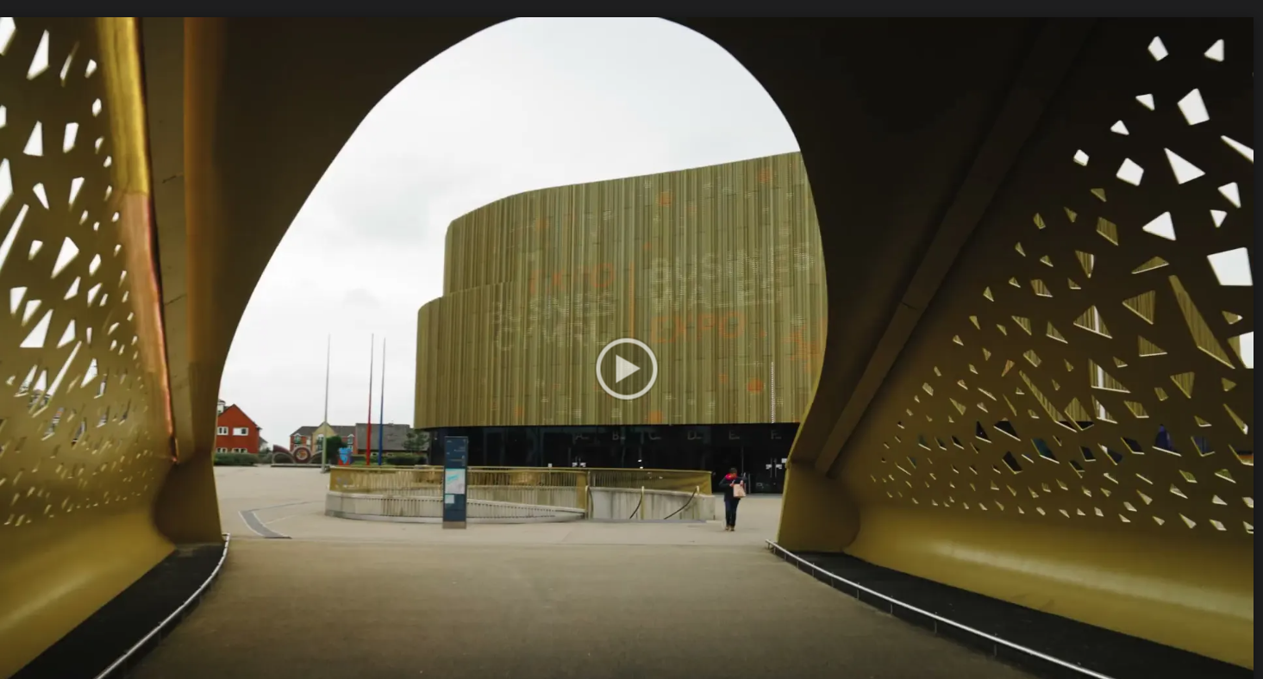
North Wales Expo
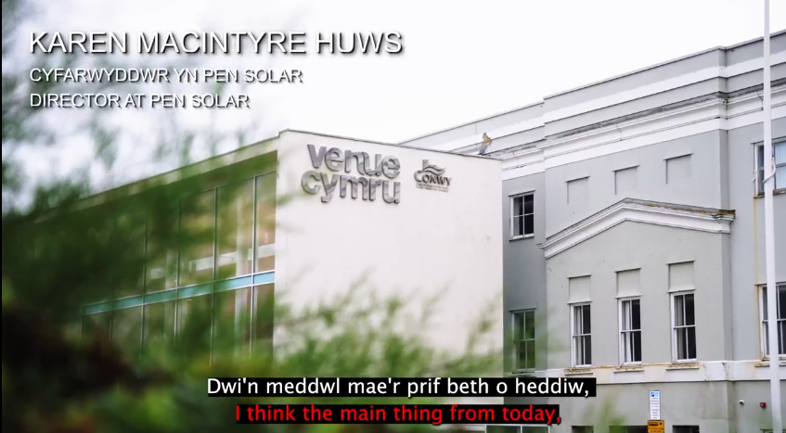

CASE STUDIES
2 video case studies pending

Supporting Food Supply in the Public Sector
Helping Welsh food and drink SMEs access public sector opportunities is key to building strong local supply chains, promoting sustainability, and supporting economic growth across Wales. By equipping businesses with the knowledge and tools to navigate procurement frameworks, we position Welsh products as a competitive choice for public sector contracts.
UPCOMING EVENTS
(Link from EMS)
FOOD PROCUREMENT FRAMEWORKS
Get a brief overview of the three main food supply frameworks for the public sector in Wales.

TUCO Framework

NHS Framework

CASE STUDIES

WPSCFG Food Framework

CASE STUDIES
Malmö, Sweden is recognised as a global leader in sustainable local food sourcing and procurement. The city prioritises sustainability, healthy options, and local suppliers across its entire food supply sector. Explore how this commitment is reflected in Malmö’s hospitals, schools, and city-wide initiatives.
Malmo – School Food Nutrition & Quality
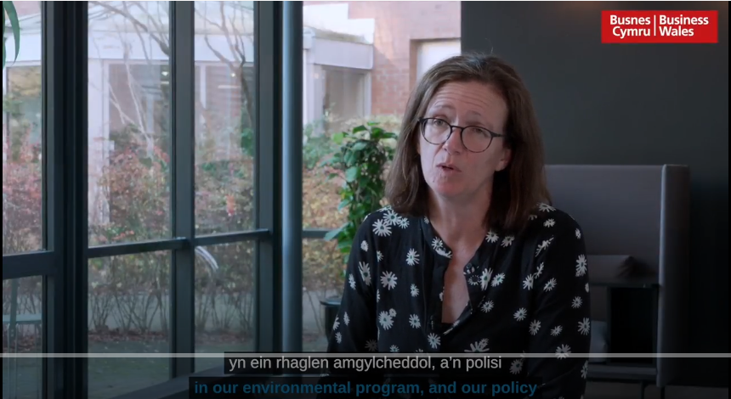

Malmo – Collaboration & Change
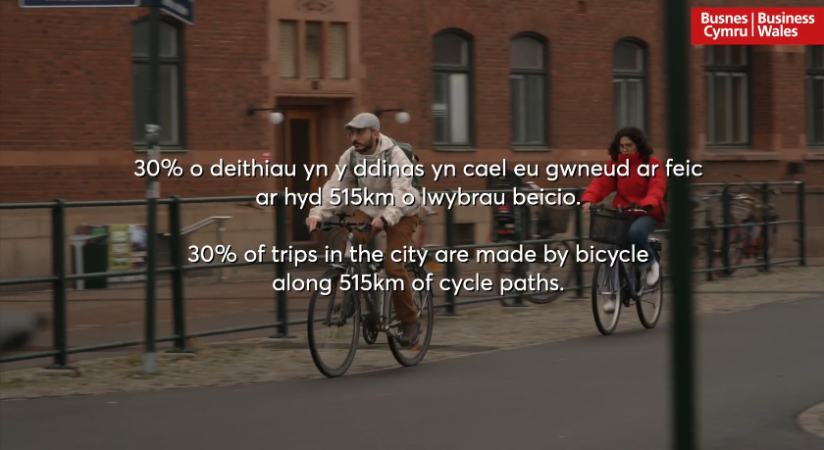

Malmo – Supplier Perspective Hufenfa
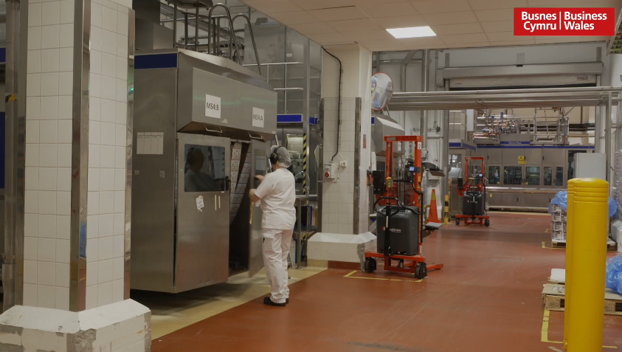
Malmo – Reform in Hospital Food
Written Case Studies
7 written case studies pending
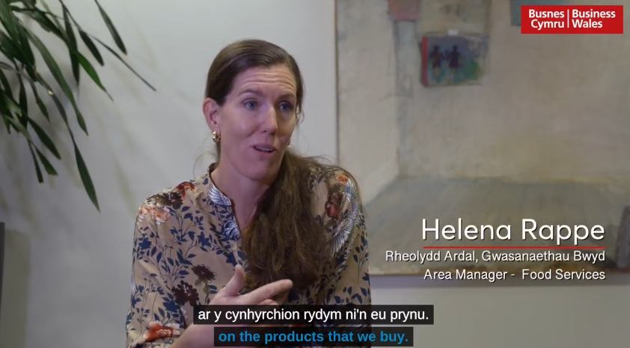

Social Partnership Public Procurement Act & The New UKG Procurement Act
Supporting Welsh SMEs to adapt to changes in procurement legislation is vital to ensuring they can thrive in a shifting public sector landscape. By working closely with Welsh Government Commercial and Procurement teams, we’re helping businesses understand what new requirements mean for them—making tendering more accessible, especially for those in the Foundational Economy. Through tailored resources, real-world case studies, and sector-specific training in areas like Construction, Energy, Food, Housing, Social Care, and Transport, we’re empowering SMEs to seize emerging contract opportunities and compete with confidence.
UPCOMING EVENTS
(Link from EMS)
OVERVIEW OF KEY CHANGES IN THE NEW PROCUREMENT ACS
Watch these short videos for a clear breakdown of the key changes in the new procurement legislation—what they mean for suppliers, and how you can adapt with confidence.

Social Partnership Public Procurement Act

The New UKG Procurement Act

RESOURCES
Legislation Guidance: Clear interpretation of new legislative requirements and their implications for suppliers.

Support and Guidance for Joint-Bidding
Enabling joint bidding is key to unlocking larger contract opportunities for local businesses. By refreshing our Joint Bidding guidance through engagement with suppliers and buyers, we’re ensuring it reflects real-world needs. We’re identifying suitable contracts and working with buyers to actively encourage collaboration—helping businesses pool their strengths and scale their capacity. Through practical case studies and tailored training, we’re supporting wider adoption of joint bidding as a smart, inclusive approach to public procurement.
UPCOMING EVENTS
(Link from EMS)

STEP-BY-STEP GUIDE TO JOINT-BIDDING
Watch this short video to learn how joint bidding works, and discover how collaboration can open up bigger opportunities for your business.

Social Partnership Public Procurement Act

CASE STUDIES
2 video case studies pending

RESOURCES
Joint Bidding Guidance: Guide reflecting buy-side and supply-side input.​

