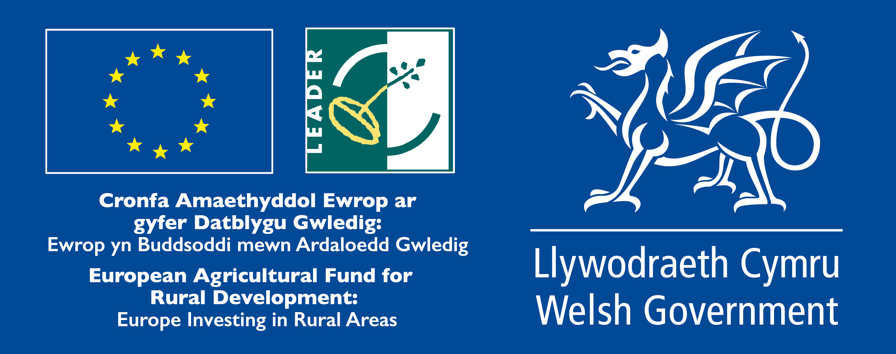

Cooperation Partner Search Request Form
(For completion by LAGs in the UK and Ireland only)

Title of the proposed project (English)

Type of project (select as many as you want)
Cooperation within the Member State of UK or Ireland  ☐ Across regions of UK  ☐ England  ☐ Northern Ireland  ☐ Scotland  ☐ Wales  ☐ Within the same region of UK or within Ireland | Transnational cooperation  ☐ Cross-border cooperation (NI and Ireland only)  ☐ With Ireland  ☐ With Northern Ireland  ☐ With other Member States (no shared border)  ☐ UK  ☐ Ireland  ☐ Other  ☐ Non EU countries

Brief summary of the project idea (max 800 characters)

Looking for partner located in the following types of areas (select as many items as you want)
☐ National / Regional borders  ☐ Inland  ☐ Island  ☐ Lakes and rivers  ☐ Coastal  ☐ Mountainous | ☐ Rural  ☐ Peri-Urban (urban/rural hinterland)  ☐ Urban  ☐ Small town  ☐ Historic centre  ☐ Densely populated residential area  ☐ Segregated/deprived neighbourhood  ☐ Isolated / remote

Looking for partner located in areas with the following assets (select as many items as you want)
☐ High Nature Value  ☐ Cropland (Arable)  ☐ Pasture | ☐ Forest  ☐ Non-productive land  ☐ Industry | ☐ Presence of relevant cultural sites  ☐ Mineral extraction  ☐ Protected areas

Topic of the project (select up to 10 items)
☐ Innovation  ☐ Research & Development  ☐ New technologies  ☐ Knowledge transfer / education / training activities  ☐ Broadband / Internet / ICT  ☐ Culture and Cultural heritage | ☐ Built environment  ☐ Village, harbour renewal  ☐ Public / community spaces / green areas  ☐ Energy efficiency, retro fitting buildings  ☐ Reconversion brownfield areas  ☐ Rural infrastructures  Social inclusion / Public services  ☐ Integrated service delivery  ☐ Social services  ☐ Transport & Mobility  ☐ Education  ☐ Health  ☐ Housing  ☐ Anti discrimination  ☐ Social enterprises  ☐ Employment / job creation  ☐ Access to labour market  ☐ Work-private life reconciliation (work life balance)  ☐ Self-employment  ☐ Upskilling  Target groups:  ☐ Youth  ☐ Women  ☐ Long term unemployed  ☐ Homeless  ☐ Elderly  ☐ Migrants  ☐ Fishermen  ☐ Marginalised communities  ☐ People with disabilities  ☐ Ex offenders  ☐ Others
Agriculture & Farming
☐ Small farms
☐ Semi-subsistence farming
☐ Organic farming
☐ Livestock
☐ Animal welfare
☐ Young farmers
☐ Urban farming
☐ Forestry
☐ Food & Drink
☐ Marketing
☐ Supply chains/Producer organisations & Cooperatives
☐ Non-food products / Crafts
☐ Business development
☐ Economic diversification
☐ Tourism / Territorial branding
☐ Natural Environment & Resources / Landscape
☐ Climate change mitigation / adaptation
☐ Local energy production / renewable energies
☐ Circular economy / bio, green economy
☐ Governance
☐ Community development
☐ Rural Urban linkages
Additional keywords: (up to 3)

about your idea & offer
Initial position / background / local context of the proposed project (max 800 characters)
The starting situation or local context in which the projects is going to operate

Proposed objectives / target group and activities (max 800 characters)

Country and /or kind of partner you are looking for (If the interest is in any EU Country please insert the words ALL EU)

Languages spoken by your LAG

Network Support Unit (NSU)

What support do you require from your NSU?

LAG CONTACT DETAILS
Member State
Region
LAG name
Contact name
E-mail
Website
Tel.
LAG Address

This Cooperation Offer is valid until
This is a mandatory field! Please provide a date after which the cooperation offer will not be valid anymore.

Date: _ _ _ _ _ _ _ _ _ _ _ _ _ _ _ _ _

For any queries relating to this form or to submit it via post or email please contact:
Name:
Address:
Email:
Telephone
<each area to insert relevant contact details>

The NSU will endeavour to acknowledge receipt of your partner search within 5 working days.
Received:  Acknowledged: | Action:  <For office use only>

